

Mediluc PHARMACY

(an online Pharmacy)

REPORT



March 15, 2022

BY: Huda Irfan(TCS2122093) Vimal Singh(TCS2122094) Gautam Singh(TCS2122095)

*ACKNOWLEDGEMENT*

In this graduation project we have been fortunate to get the support and encouragement.

 We would like to earnestly acknowledge the sincere efforts and valuable time given by our project advisor HOD PROF MANOJ SINGH.

His valuable guidance and feedback have got us through each and every step of the process which has helped us in completing this project.

Also, I would like to mention the support system and consideration of our parents who have always been there in my life.

Without them, we could never had completed this task.

Thanks a lot.

TABLE OF CONTENT

* INTRODUCTION
  + Proposed system
  + Project description
  + Project details
  + Technology used
* Status Report
* Gantt Chart
* ER-diagram
* Database design
* Stakeholders AND Modules
* Event Table
* UML Diagram
  + Use case
  + Sequence
* Function Point Analysis
* Chi Square Test
* Snapshot of the website
* Source Code
* Feedback
* Conclusion

INTRODUCTION

*E-commerce is fast gaining ground as an accepted and used business paradigm. More and more business houses are implementing web sites providing functionality for performing commercial transactions over the web. It is reasonable to say that the process of shopping on the web is becoming commonplace. The objective of this project is to develop a general*

*purpose e-commerce pharmacy store where any kind of medicine can be bought from the comfort of home through the internet.*

*An online pharmacy is a virtual store on the internet where customers can browse the catalog and select products of interest. The selected items may be collected in a shopping cart. At checkout time, the items in the shopping cart will be presented as an order. At that time, more information will be needed to complete the transaction. Usually, the customer will be asked to fill or select a billing address. a shipping address, a shipping option, and payment information such as phone pay, or Cash on Delivery. An e-mail notification is sent to the customer as soon as the order is placed.*

PROPOSED SYSTEM:

*The Online Pharmacy is easy to use and order. The customer selects the required medicines and orders them by a single click. Before it, the customer needs to create a login account and fill all the details like name, address, any id no…Etc.  The client can able to view the status of the medicines. The business goal for the application is to provide the medicines to all the people & admin will provide the supplier details.​*

*The consumer can view the medication details ​*

*A profile will be maintained to keep record of consumer ​*

*Vendor can view the data related to a specific medicine ​*

PROJECT DISCRIPTION:

*We have developed an e-commerce website for online pharmacy. After logging in, the available products/services in the system are listed to the user. Any medicine can be searched in the search box. The user can also filter out the medicines based on categories provided. Paging functionality for listing products/services has been implemented. After selecting a particular medicine, the user can update the quantity of the product. User can also update items in the cart, like removing items from the cart and updating the product’s quantity. The project also shows the history of purchases or saved lists for the user. After selecting the products, the user goes for the payment option and enters the billing details. In the billing section, promo code or deal code can be applied, resulting in some discount for the final bill due. For the admin part : The admin can view, delete and insert the products and category to the table. He/she can also view the users and their orders.*

*Additional feature: The user can enter a coupon code to get a discount on his/her total bill.*

An Admin has some extra privilege including all privilege of visitor and user.

✓ Admin can add products, edit product information and add/remove product.

✓ Admin can add user, edit user information and can remove user.

✓ Admin can ship order to user based on order placed by sending confirmation mail.

PROJECT details:

Home Page: main page of the website

About us Page: The page is about our pharmacy.

Shop page: The page is for products

Login page: admin login page and user login page

Admin pages

View product page: page for edit and delete product

View order page: page for edit orders

Insert category page: page for edit category

Deals page: page for adding and deleting deals

TECHNOLOGY USED:

* HTML
* CSS
* JAVA SCRIPT
* PHP

Status Report

|  |  |  |  |  |  |
| --- | --- | --- | --- | --- | --- |
| Sr.No | Phase | Duration | Start Date | End Date | Sign |
| 1 | Project Planning | 5 | 22-Nov 2021 | 26-Nov 2021 |  |
| 2 | Analysis | 11 | 27-Nov 2021 | 7-Dec 2021 |  |
| 3 | Design | 18 | 8 –Dec 2021 | 26-Dec 2021 |  |
| 4 | Coding and testing | 52 | 27-Dec 2021 | 18-Feb 2022 |  |
| 5 | Documentation | 90 | 27-Nov 2021 | 25-Feb 2022 |  |

GANTT CHART

(23 NOV – 25 FEb):

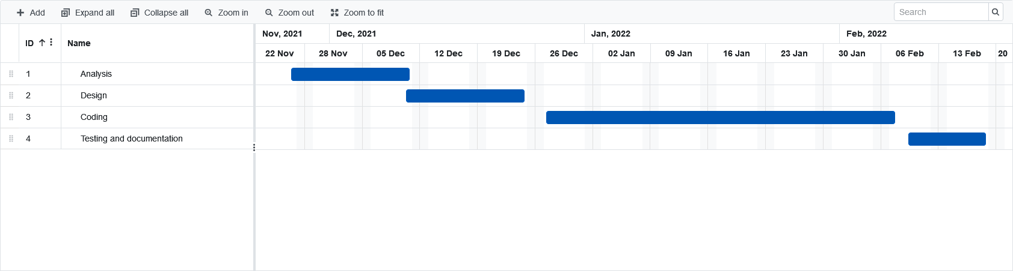

ER DIAGRAM

An entity relationship diagram (ERD), also known as an entity relationship model, is a graphical representation that depicts relationships among people, objects, places, concepts or events.

Based on ER diagram Data Bae is created.

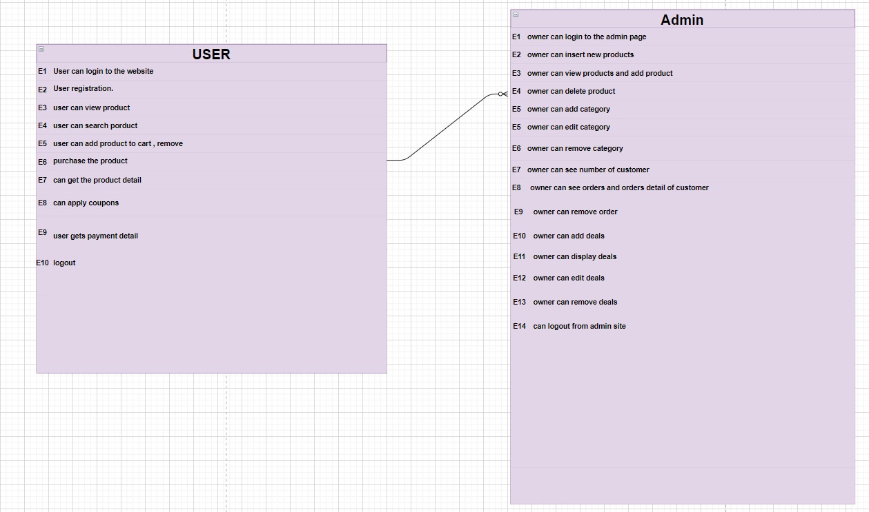

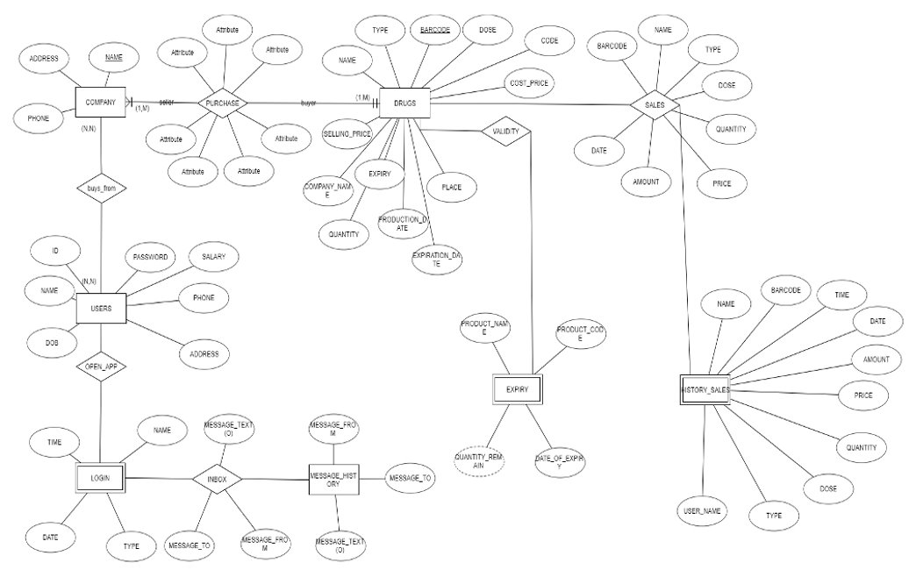

DATA BASE DESIGN:

We have used Mysql data base table for project with data base name as

Pharmacy_db.

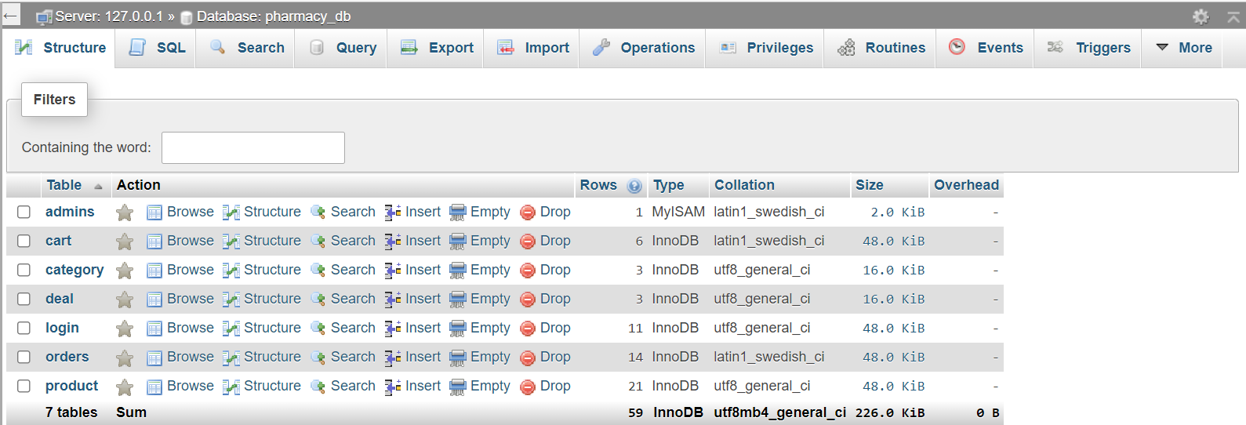

Further Data Base is divided into 7 tables as admins, cart, category, deal, login, orders, product.

ADMIN TABLE:

This table store data of user such as email id and password.

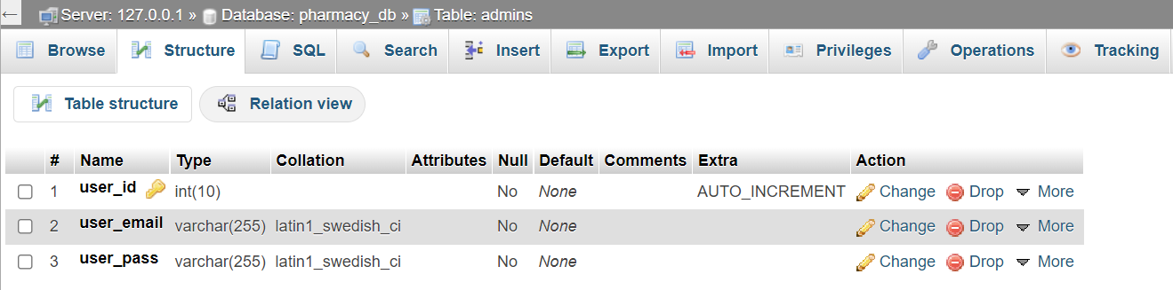

CART TABLE:

The table is for storing cart detail.

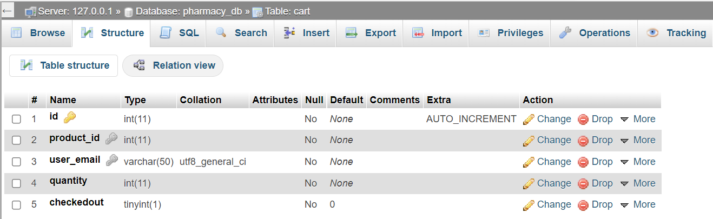

CATEGORY TABLE:

Category table in data base store the sub category of the medicine which they are belong to.

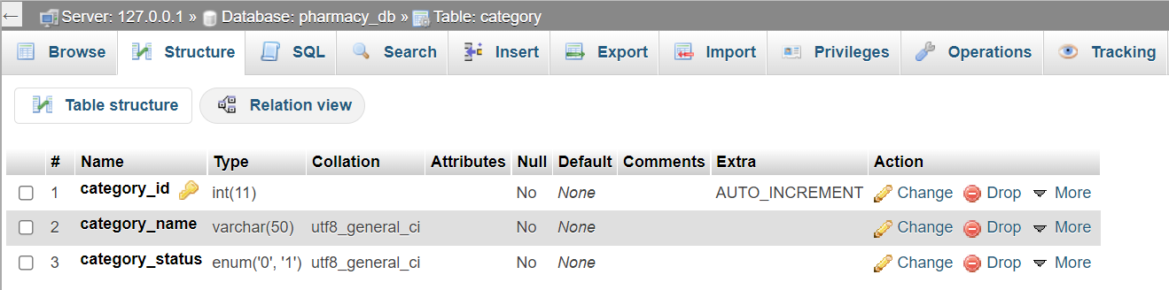

DEAL TABLE:

Deal table is for deals on medicine which consist of deal name with cost.

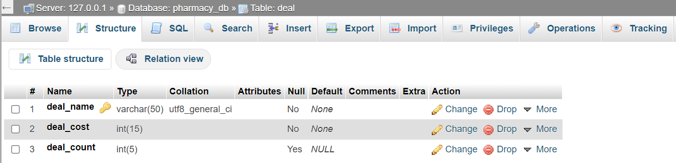

LOGIN TABLE:

This table is for obtaining credentials from the user for login. Which consist of email as primary key.

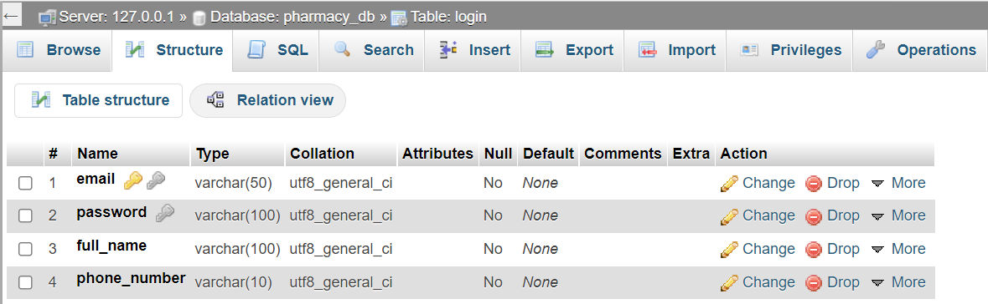

ORDER TABLE:

This table is for order detail consisting of user details, with primary key as order id.

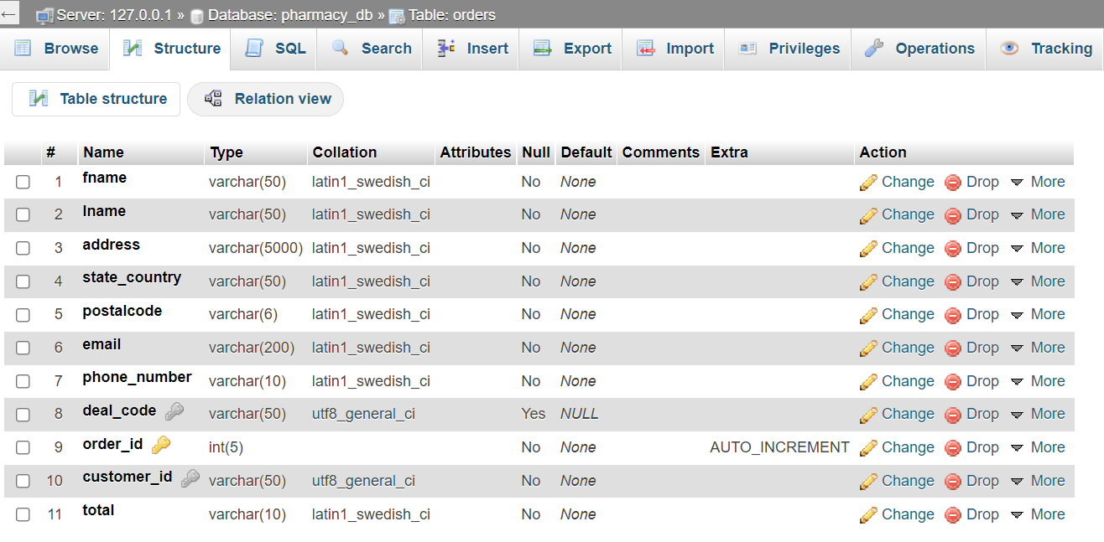

PRODUCT TABLE:

Table is for product with attribute as id, name etc….. with primary key order_id and unique key product_name.

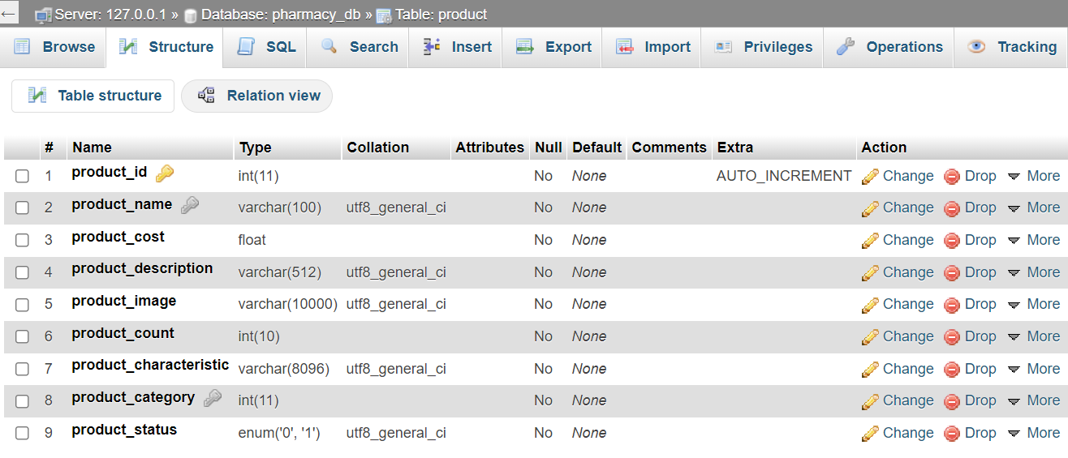

Stake holder and modules:

A stakeholder is a member of "groups without whose support the organization would cease to exist".

Modules are the sub-models of the project.

STAKEHOLDER:

* Customer
* Admin
* Delivery person

MODULES:

* Login/Registration ​
* Customer Login
* Admin page
* Homepage​
* About us
* Buy Page​
* Vendor Restock Page​
* Products​
* Purchase Medicine​
* View Order​
* Category
* Deals

EVENT TABLE RELATED TO EACH MODULES:

*ADMIN TABLE:*

|  |  |  |  |  |  |  |
| --- | --- | --- | --- | --- | --- | --- |
| Sr.No | Event | Trigger | Source | Activity | Response | Destination |
| 1 | Login | Logs in to the system | Admin | Validates the loggin info | Opens the administration section | Database |
| 2 | Insert new products | Inserts the product | Admin | Adds the product into the database | Displays the message product added | Database |
| 3 | View Products | Checks the product | Admin | Checks if the product is available | Displays the product | Database |
| 4 | Delete product | Delete product | Admin | Deletes the product from the database | Displays the message product deleted | Database |
| 5 | Add category | Insert a new category | Admin | Insert new category into the database | Category added | Database |
| 6 | Edit category | Update category | Admin | Update the category | Category updated | Database |
| 7 | Remove Category | Delete category | Admin | Delete the category from the database | Category deleted | Database |
| 8 | Display Customer | View customer | Admin | View customer details from the database | Customer details | Database |
| 9 | Display order | View order details | Admin | View order details from the database | Show order details | Database |
| 10 | Remove order | Delete order | Admin | Delete the order details from the database | Order details deleted | Database |
| 11 | Add deals | Insert deals | Admin | Add a new deal into the database | Deal added | Database |
| 12 | Display deals | View deals | Admin | View all the deals from the database | Displays all the deals | Database |
| 13 | Edit deals | Update deals | Admin | Update the deal in the database | Deal updated | Database |
| 14 | Remove deal | Delete deal | Admin | Delete the deal from the database | Deal deleted | Database |
| 15 | Logout | Log out | Admin | Logs out from the system | Logged out | System |

USER EVENT TABLE:

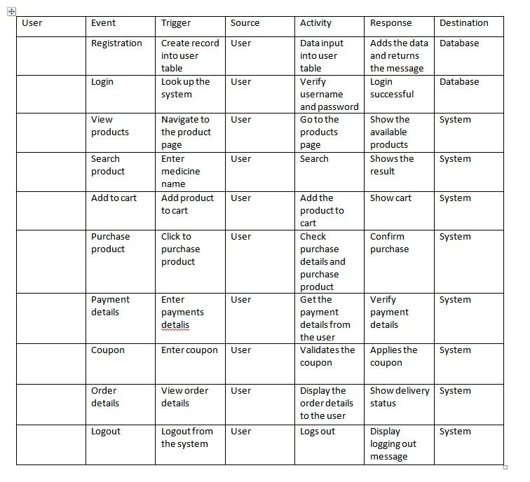

Diagram REPRESENTATION

*Use case diagram:*

*admin*

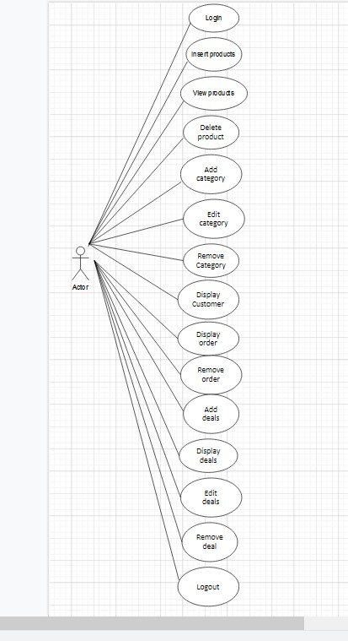

User:

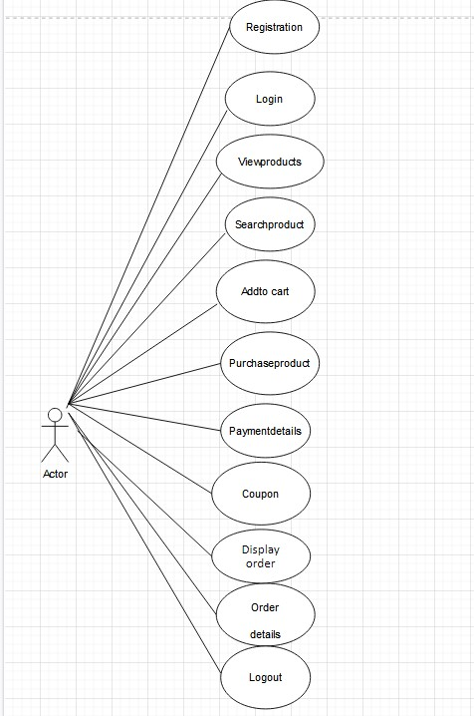

SEQUENCE DIAGRAM:

USER:

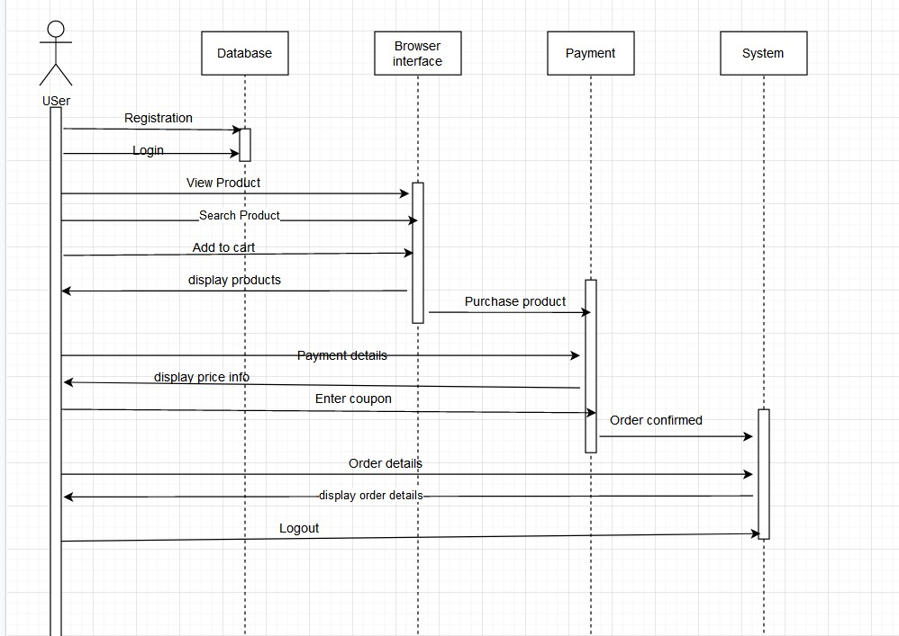

ADMIN:

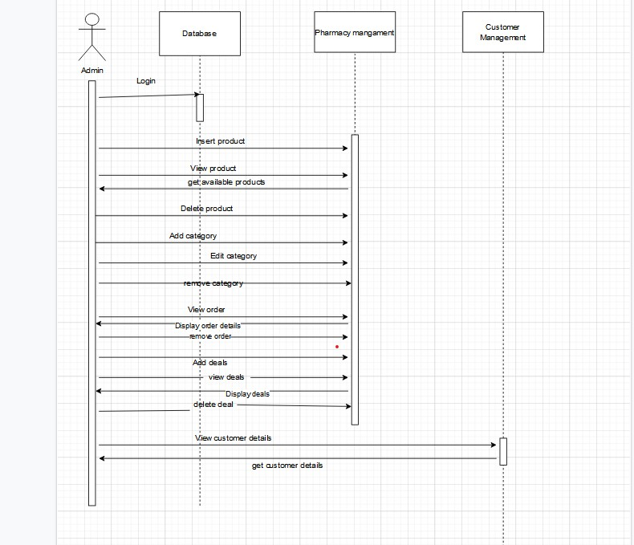

Activity DIAGRAM:

USER:

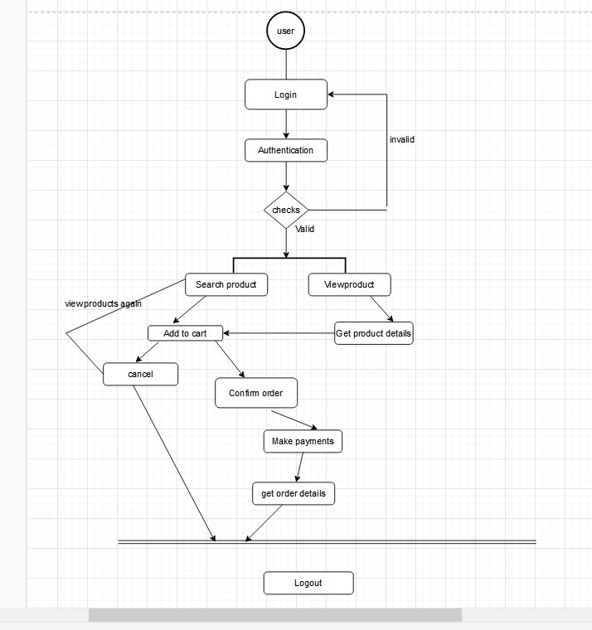

ADMIN:

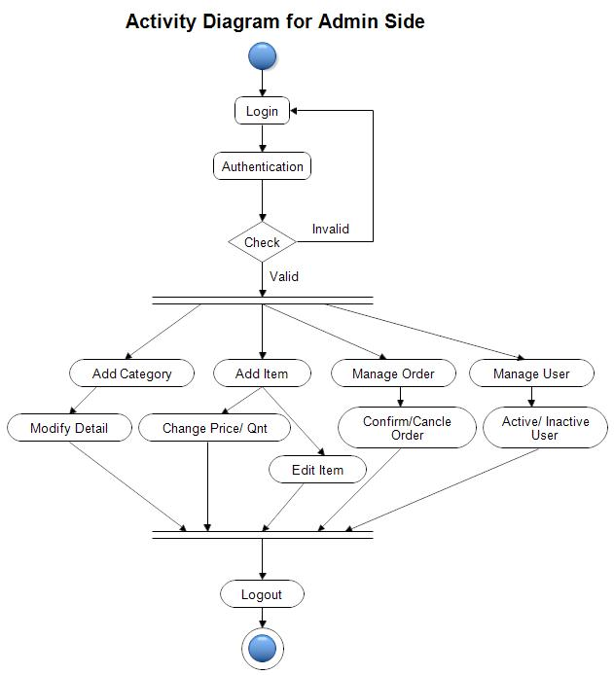

Collaboration diagram :

ADMIN:

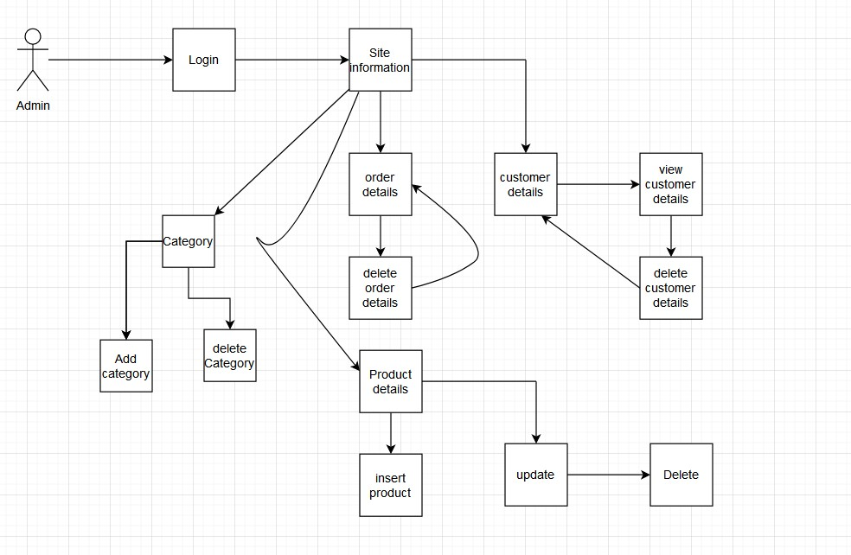

User :

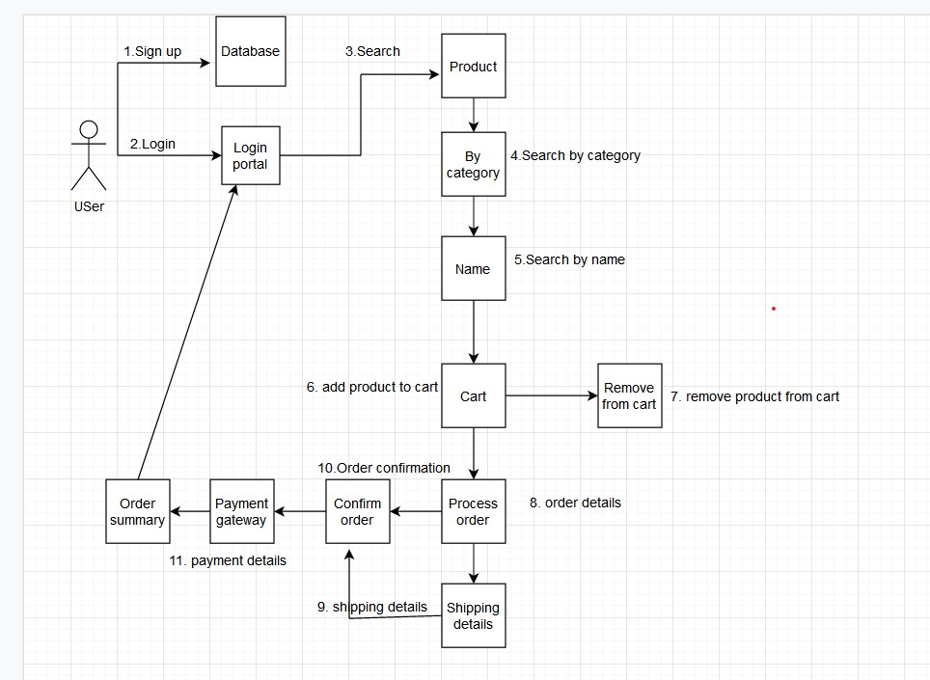

Pharmacy management diagram

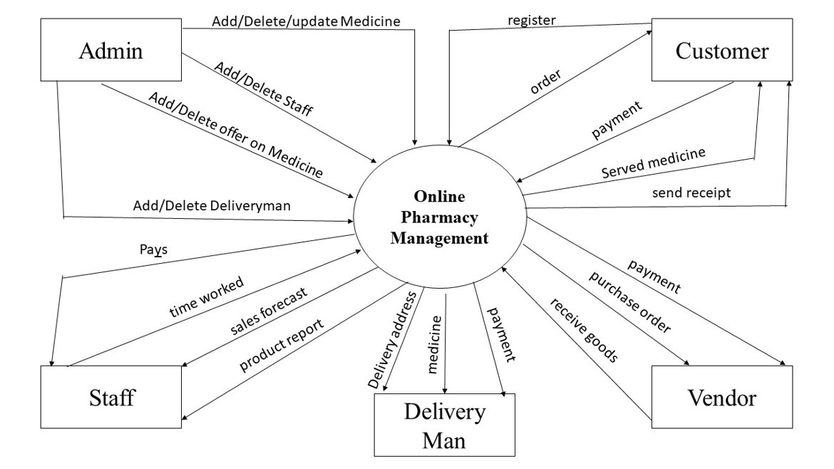

Function Point Analysis (FPA)

Itis a method or set of rules of Functional Size Measurement. It assesses the functionality delivered to its users, based on the user's external view of the functional requirements.

First step is to get the detail of input and output in project.

Input and output details:

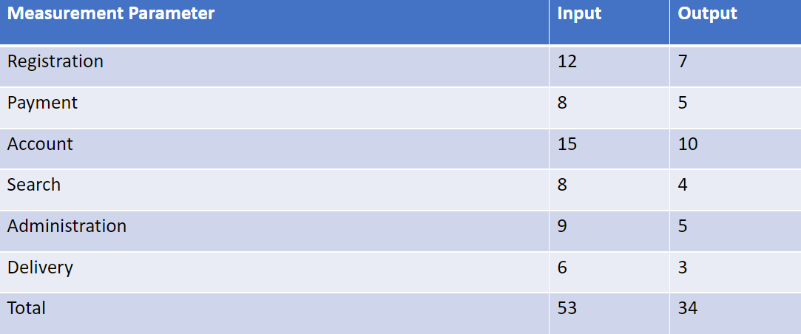

DETERMINING THE VALUE OF LOW, HIGH AND AVERAGE.

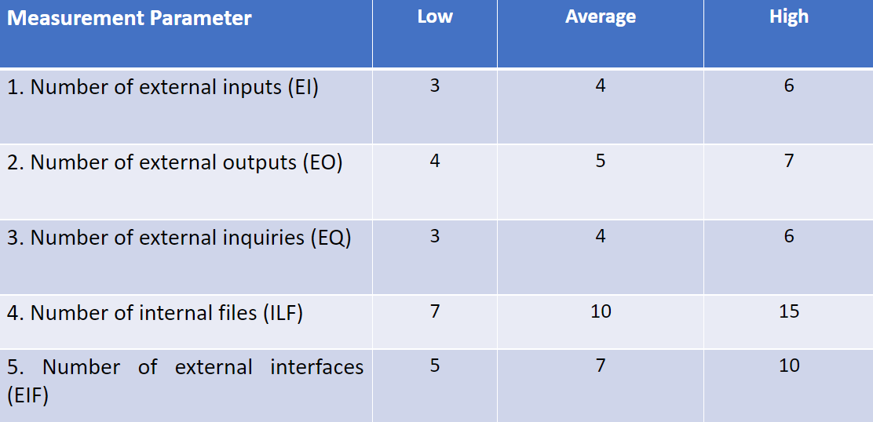

FINDING THE TOTAL OF WEIGHING FACTOR:

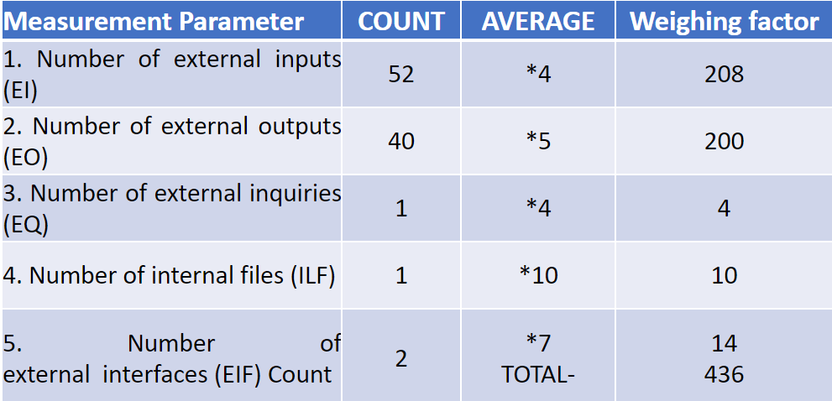

FINDING FUNCTION POINT:

F = 14 * scale​

​

F=14*3             (as average scale) ​

F=42​

For Complexity Adjustment Factor (CAF)​

CAF = 0.65 + (0.01 * F)​

CAF = 0.65 + (0.01 * 42)​

CAF = 0.65 + (0.42)​

CAF = 1.07​

FUNCTION POINT = TOTAL * CAF​

FUNCTION POINT = 436 * 1.07​

FUNCTION POINT = 466.52

FINDING ESTIMATED LABOR COST:

Function Point = 466​

If each member completes 60 functional point ​

60 x 3 = 180 functional point per month​

466/180 = 2.5 months​

If each programmer is paid Rs.35,000 per month​

105,000 x 2.5= 262,500​

Total Labor Cost = Rs.262,500​.

**T-TEST**

**Critical value for T-test**

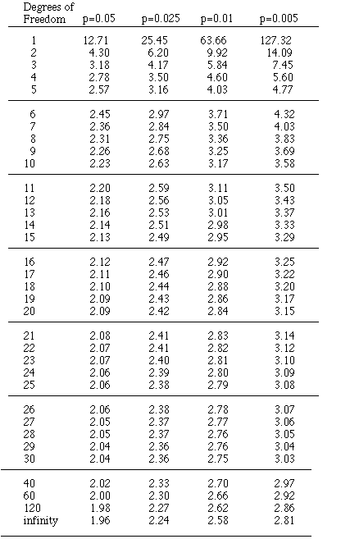

**T-test formula**

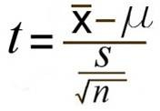

X is the mean of the group

s^2 is standard deviation

n is the sample size

U is the proposed constant

**Standard deviation formula**

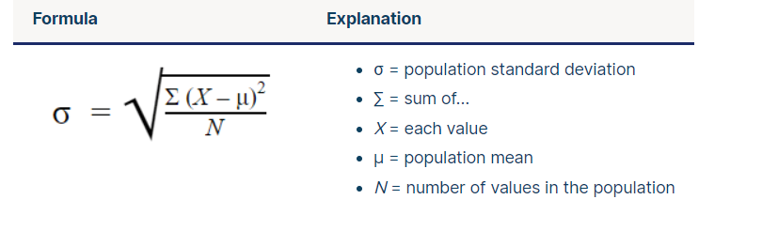

**We are using probability of p=0.005**

**T-test for ADMIN FEATURE**

**Form link.**

<https://docs.google.com/forms/d/1C0gxZmjZr0U8uqCEnG9KAZMQxhVo4ugBMA0JtanUvDA/edit?usp=sharing>

H0= most of the people are satisfied

H1= most of the people are not satisfied

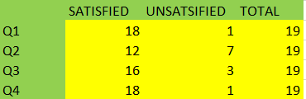

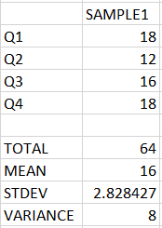

T=mean-value/(standard deviation/number of sample^2)

T=16-12/(8/19^2)

T=4/1.8

T=2.2

Tcri=3.20

Since, T<Tcri

Therefore, we accept H0

That is most of the people are satisfied with the admin feature

**T-test for SHOPPING FEATURE**

**Form link.**

<https://docs.google.com/forms/d/1C8nuvvQCVMIBQ-RnWGxvmLZuXoyJXLRK6GlF3BtNp_Y/edit#responses>

H0= most of the people are satisfied

H1= most of the people are not satisfied

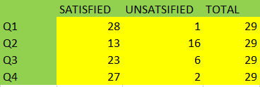

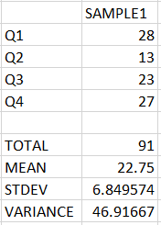

T=mean-value/(standard deviation/number of sample^2)

T=22.75-13/(46.9/29^2)

T=9.75/8.8

T=1.1

Tcri=3.14

Since, T<Tcri

Therefore, we accept H0

That is most of the people are satisfied with the login feature

**T-test for CART FEATURE**

**Form link.**

[**https://docs.google.com/forms/d/1F2ogNJrzTZO9qgkgoJYpIOtCqC-Q9kfQqNew3W3JAa0/edit**](https://docs.google.com/forms/d/1F2ogNJrzTZO9qgkgoJYpIOtCqC-Q9kfQqNew3W3JAa0/edit)

H0= most of the people are satisfied

H1= most of the people are not satisfied

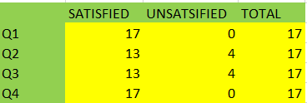

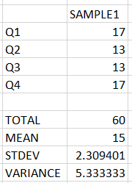

T=mean-value/(standard deviation/number of sample^2)

T=15-13/(5.3/17^2)

T=15-13/(5.3/4.1)

T=1.6

Tcri=4.3

Since, T<Tcri

Therefore, we accept H0

That is most of the people are satisfied with the payment feature

**T-test for login and registration FEATURE**

**Form link.**

<https://docs.google.com/forms/d/1C0gxZmjZr0U8uqCEnG9KAZMQxhVo4ugBMA0JtanUvDA/edit?usp=sharing>

H0= most of the people are satisfied

H1= most of the people are not satisfied

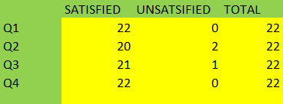

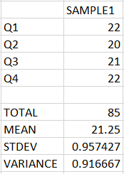

T=mean-value/(standard deviation/number of sample^2)

T=21.75-20/(0.9/22^2)

T=1.75/(0.19)

T=2.73

Tcri=3.25

Since, T<Tcri

Therefore, we accept H0

That is most of the people are satisfied with the cart feature

**T-test for CART FEATURE**

**Form link.**

[**https://docs.google.com/forms/d/1F2ogNJrzTZO9qgkgoJYpIOtCqC-Q9kfQqNew3W3JAa0/edit**](https://docs.google.com/forms/d/1F2ogNJrzTZO9qgkgoJYpIOtCqC-Q9kfQqNew3W3JAa0/edit)

H0= most of the people are satisfied

H1= most of the people are not satisfied





T=mean-value/(standard deviation/number of sample^2)

T=15-13/(5.3/17^2)

T=15-13/(5.3/4.1)

T=1.6

Tcri=3.25

Since, T<Tcri

Therefore, we accept H0

That is most of the people are satisfied with the cart feature

CHI SQUARE TEST

Link for form

<https://docs.google.com/forms/d/1-NioU1vnnWlXNVwUpiCkCD33ugL4tsXY8NmG7mZ7RCI>

website for comparison

<https://pharmeasy.in/>

H0: The online website is most preferred by user

H1: The new website is most preferred by user

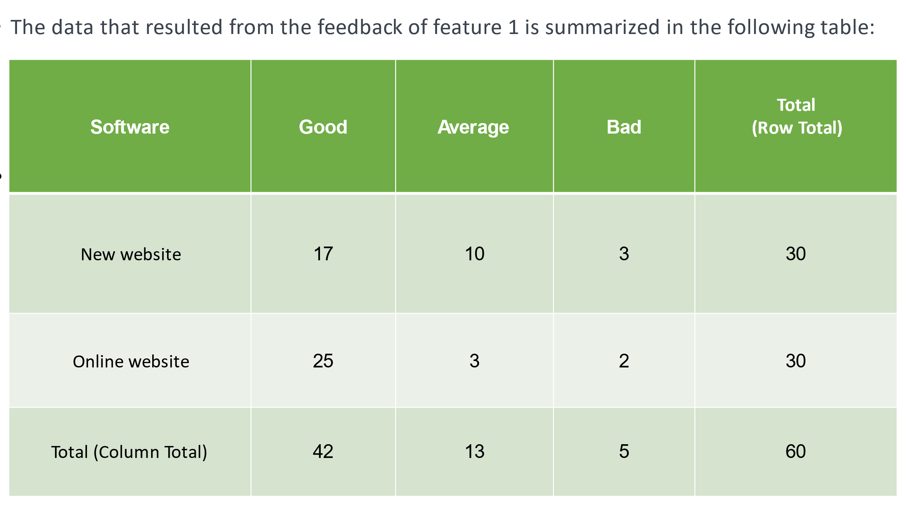

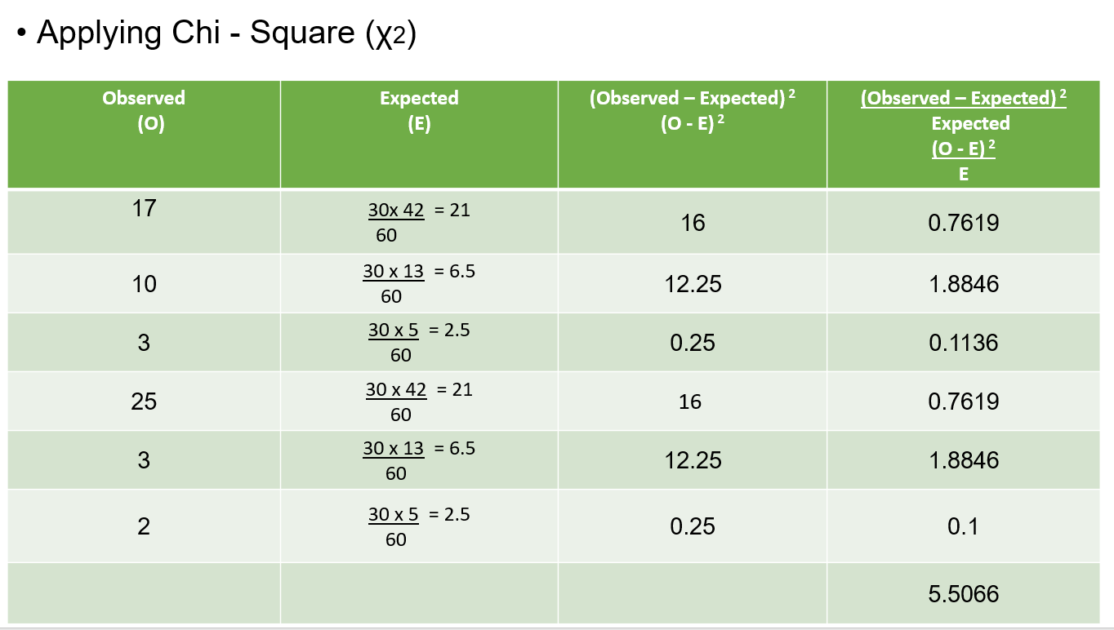

**Calculateded Chi-Square:**

Σ(O-E) 2 / E = 5.5066

χ2 = Σ(O-E) 2 / E = 5.5066(Calculated Chi-Square Value)

**Tabulated Chi-Square:**

First we need a "Degree of Freedom"

Degree of Freedom(V) = (rows − 1) × (columns − 1)

For our example we have 2 rows and 3 columns:

V = (2 − 1)(3 − 1) = 1×2 = 2

Assuming that we have an alpha level of significance equal to 0.001, it is time to use the chi square distribution table.

For χ2 **2,0.001**= 13.816 (Tabulated Chi-Square Value)

The calculated value of χ2 is less than the tabulated value, hence the H0 (null Hypothesis) is accepted.

Hence, the user preferred the online website as more suitable in terms of user interface

H0: The online website has more features

H1: The new website has more features

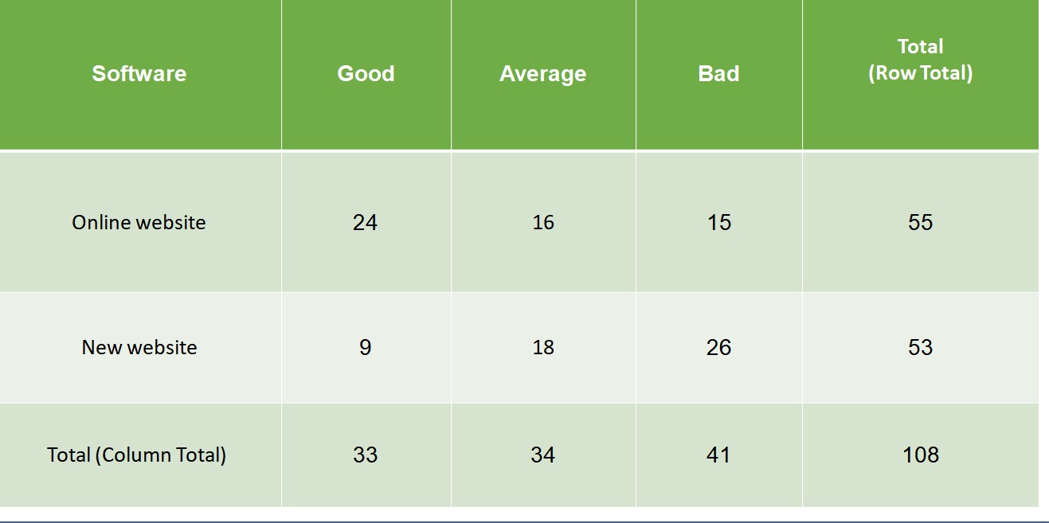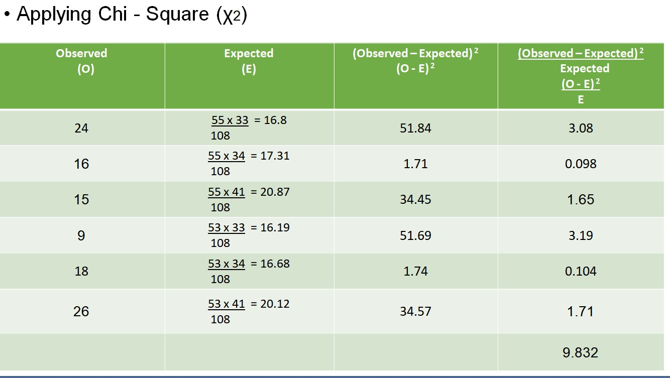

* **Calculateded Chi-Square:**
* Σ(O-E) 2 / E = 9.382
* χ2 = Σ(O-E) 2 / E = 9.382 (Calculated Chi-Square Value)
* **Tabulated Chi-Square:**
* First we need a "Degree of Freedom"
* Degree of Freedom(V) = (rows − 1) × (columns − 1)
* For our example we have 2 rows and 3 columns:
* V = (2 − 1)(3 − 1) = 1×2 = 2
* Assuming that we have an alpha level of significance equal to 0.001, it is time to use the chi square distribution table.
* For χ2 **2,0.001**= 13.816 (Tabulated Chi-Square Value)
* The calculated value of χ2 is less than the tabulated value, hence the H0 (null Hypothesis) is accepted.
* Hence, the online website has more features than our website

H0: The online website has better interface

H1: The new website has better interface

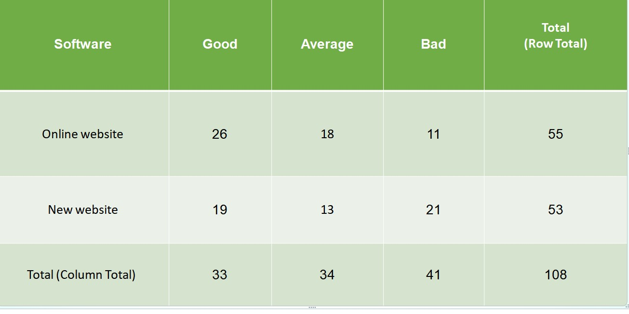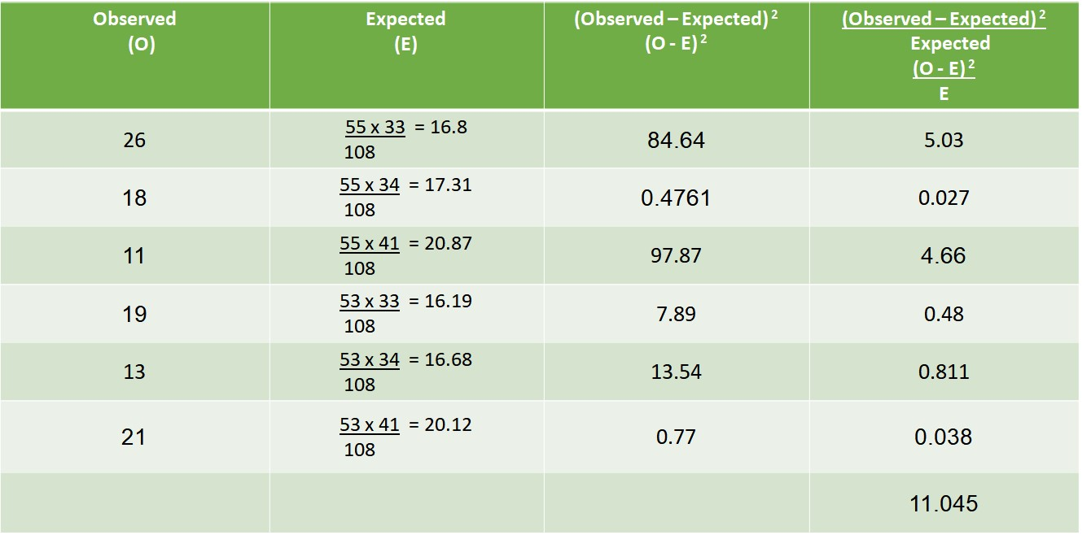

* **Calculateded Chi-Square:**
* Σ(O-E) 2 / E = 11.045
* χ2 = Σ(O-E) 2 / E = 11.045 (Calculated Chi-Square Value)
* **Tabulated Chi-Square:**
* First we need a "Degree of Freedom"
* Degree of Freedom(V) = (rows − 1) × (columns − 1)
* For our example we have 2 rows and 3 columns:
* V = (2 − 1)(3 − 1) = 1×2 = 2
* Assuming that we have an alpha level of significance equal to 0.001, it is time to use the chi square distribution table.
* For χ2 **2,0.001**= 13.816 (Tabulated Chi-Square Value)
* The calculated value of χ2 is less than the tabulated value, hence the H0 (null Hypothesis) is accepted.
* Hence, the online website has better cart feature than ours

H0: The online website has more features

H1: The new website has more features

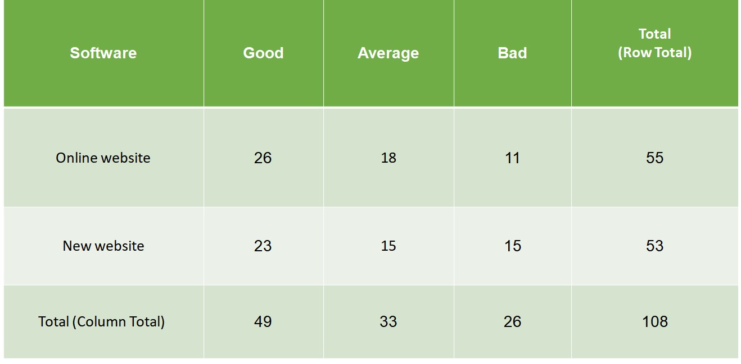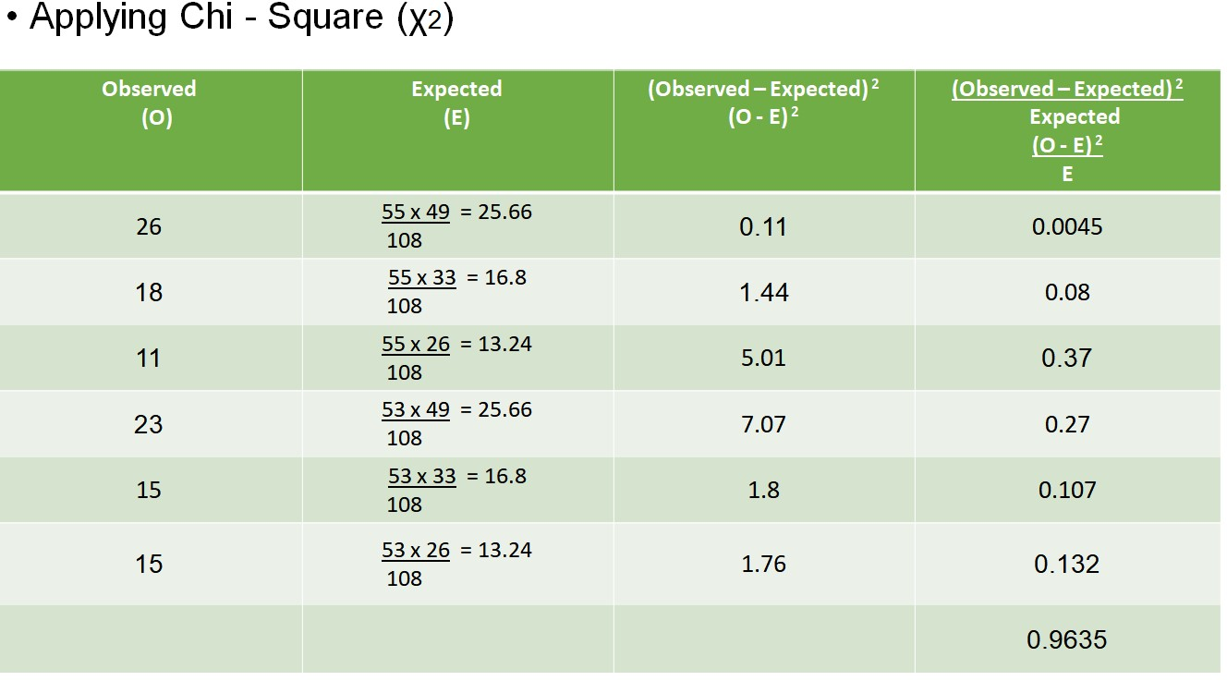

* **Calculateded Chi-Square:**
* Σ(O-E) 2 / E = 0.9635
* χ2 = Σ(O-E) 2 / E = 0.9635 (Calculated Chi-Square Value)
* **Tabulated Chi-Square:**
* First we need a "Degree of Freedom"
* Degree of Freedom(V) = (rows − 1) × (columns − 1)
* For our example we have 2 rows and 3 columns:
* V = (2 − 1)(3 − 1) = 1×2 = 2
* Assuming that we have an alpha level of significance equal to 0.001, it is time to use the chi square distribution table.
* For χ2 **2,0.001**= 13.816 (Tabulated Chi-Square Value)
* The calculated value of χ2 is less than the tabulated value, hence the H0 (null Hypothesis) is accepted.
* Hence, the online website has better cart module

SCREENSHOT OF WEBSITE

Home page:

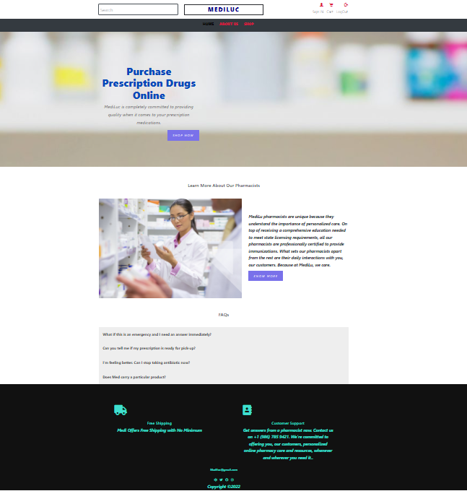

about page:

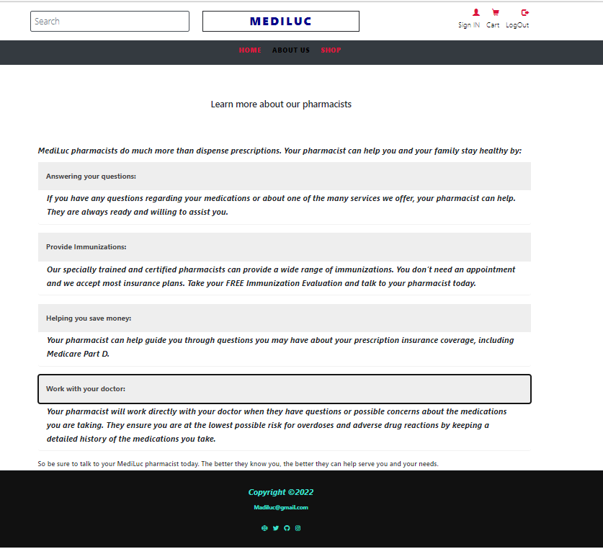

shop page:

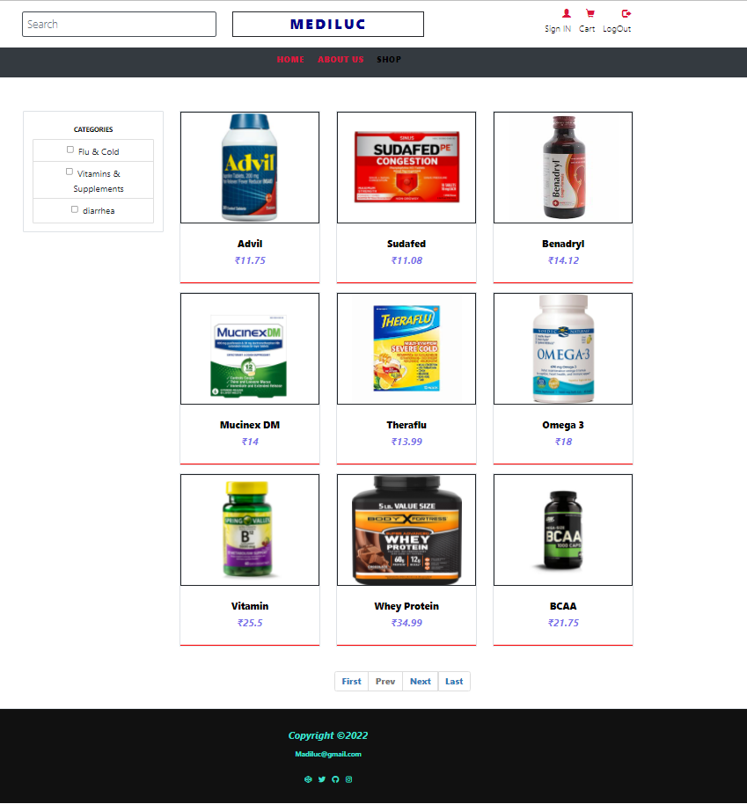

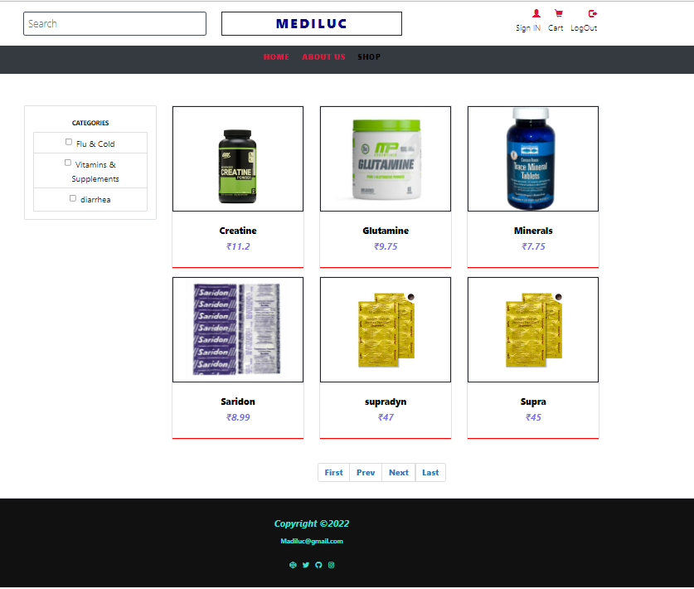

Sign in page:

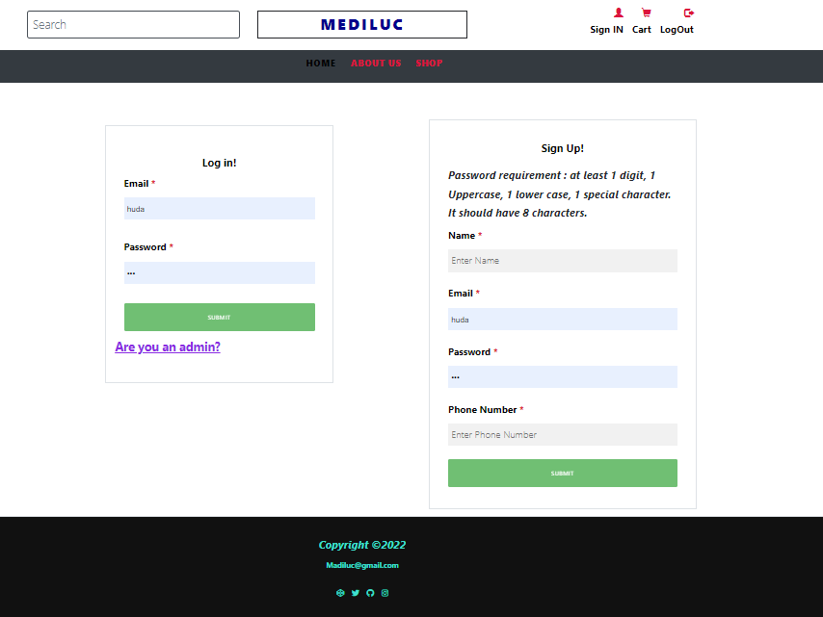

User login:

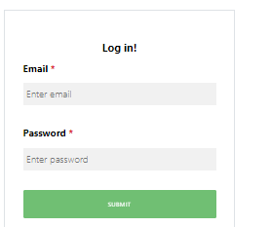

Selecting product:

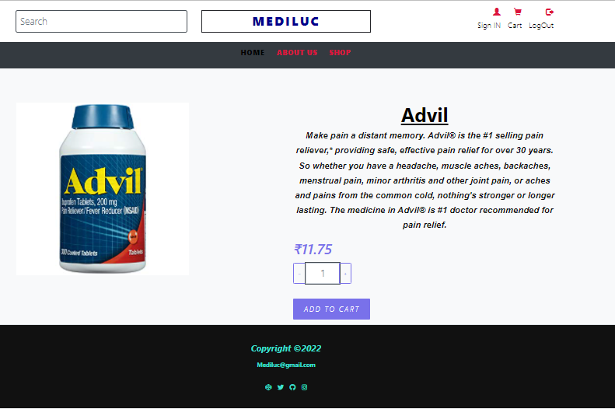

Adding product to cart:

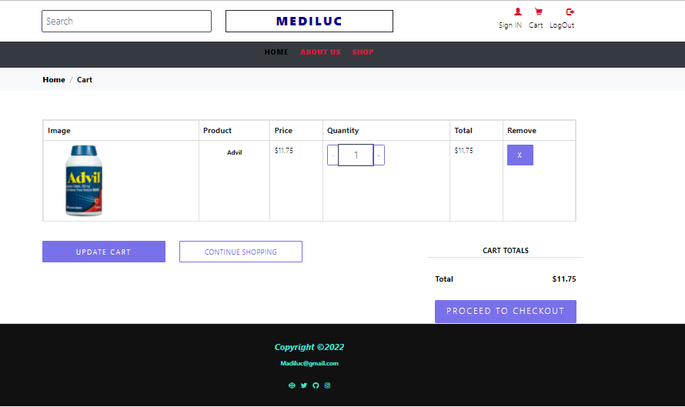

Check out process:

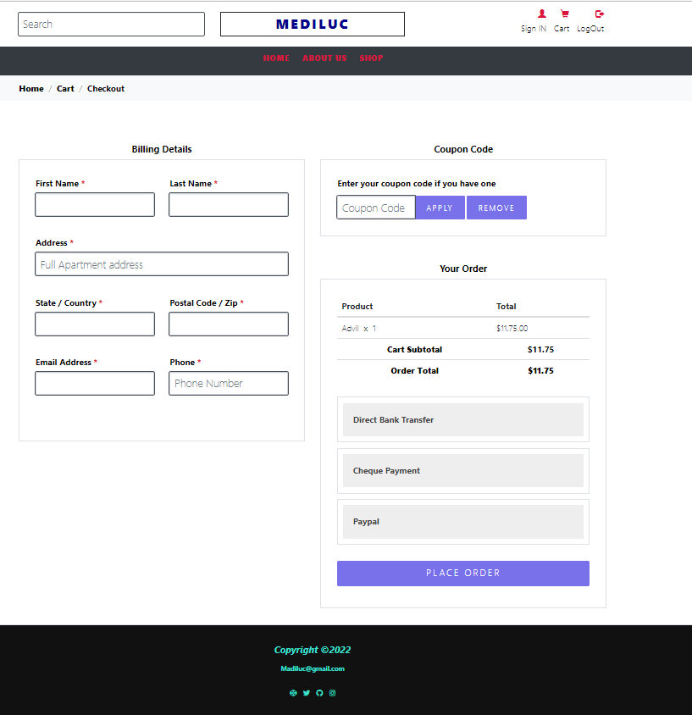

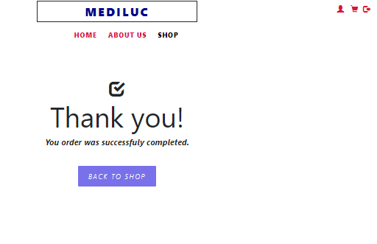

Admin login page:

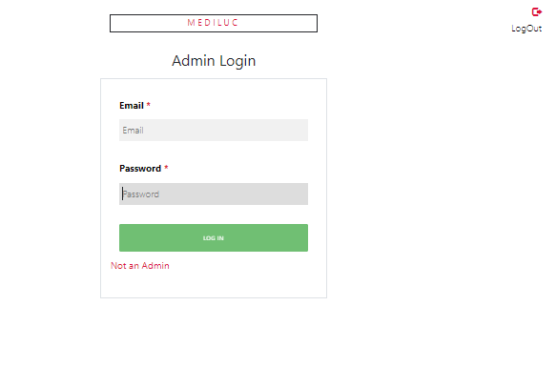

Admin page:

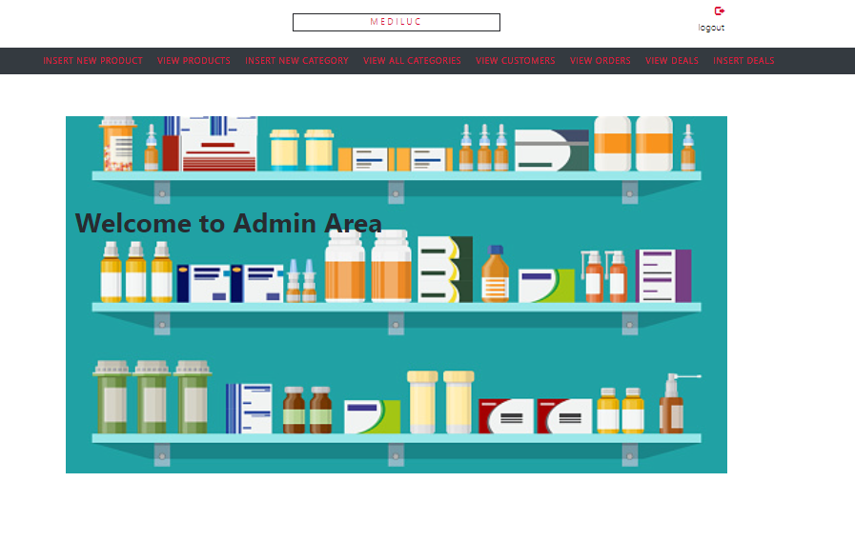

Insert product page:

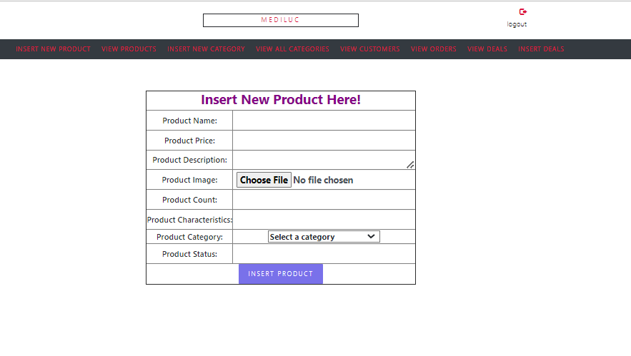

Insert category page:

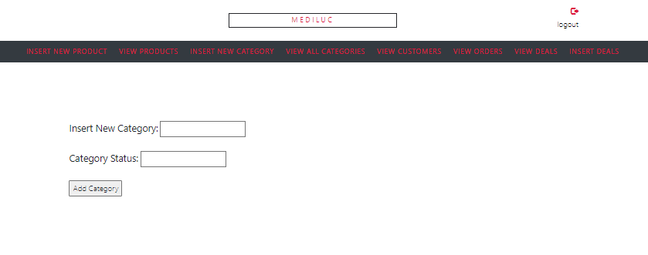

View product page:

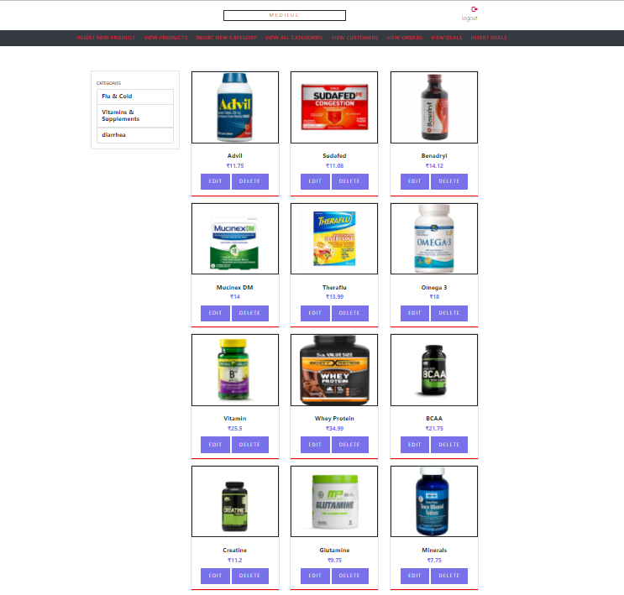

View category page:

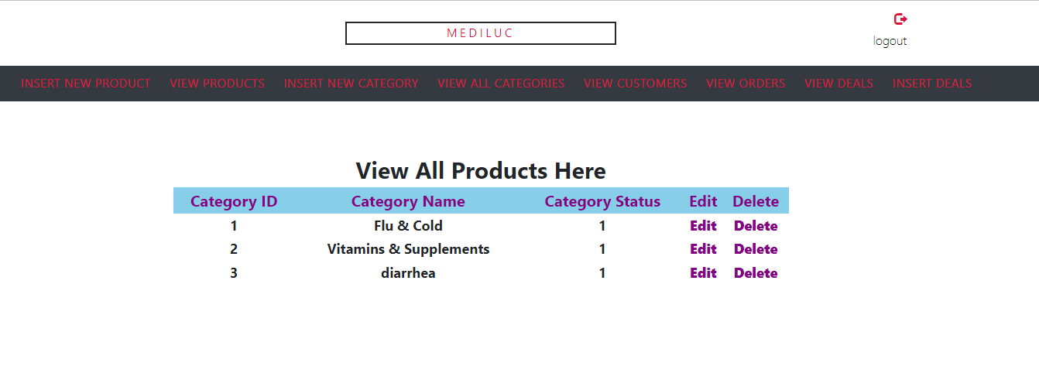

View customer:

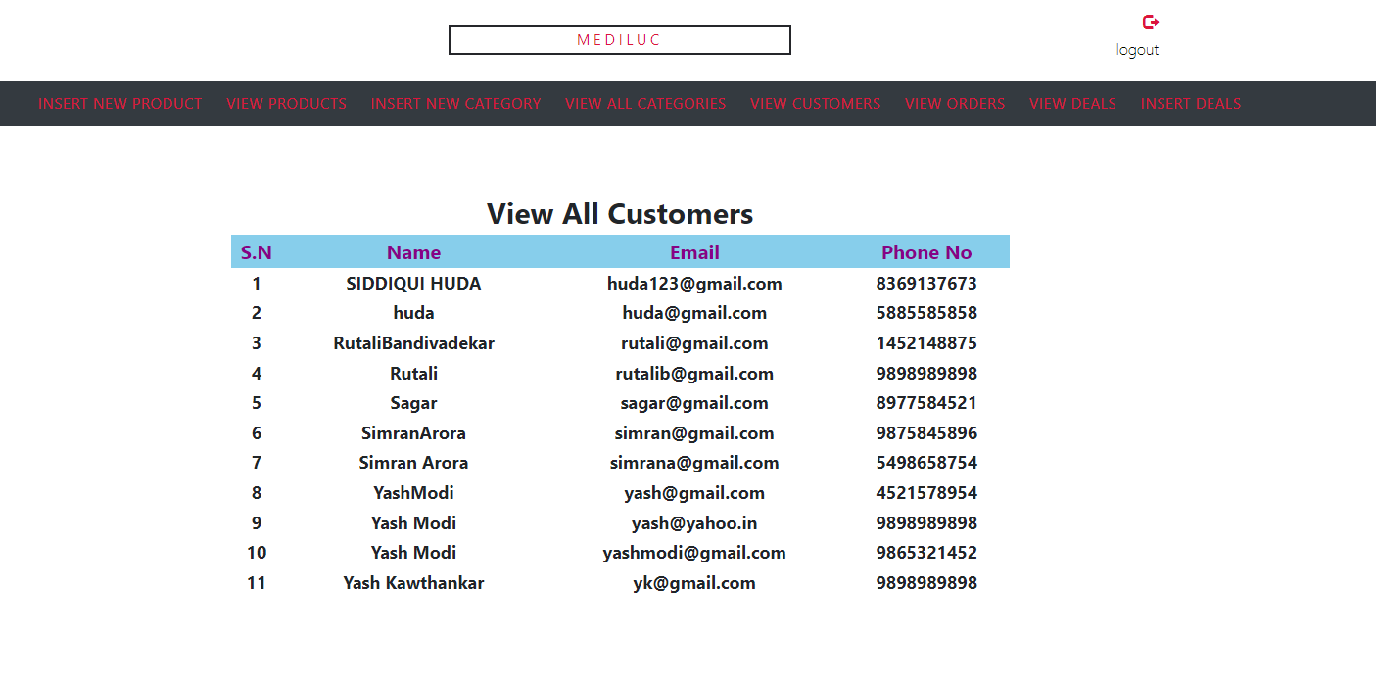

Insert deals:

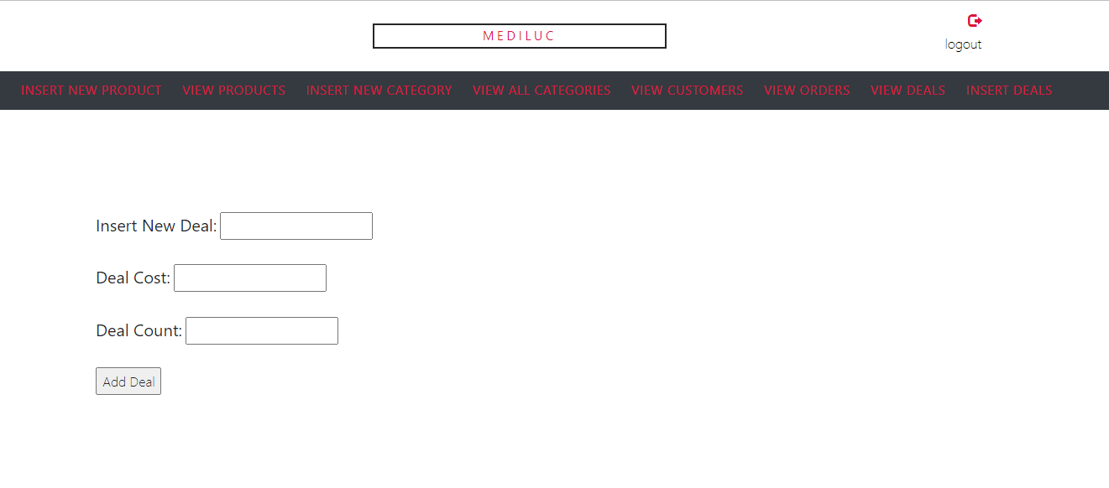

Code

Css code:

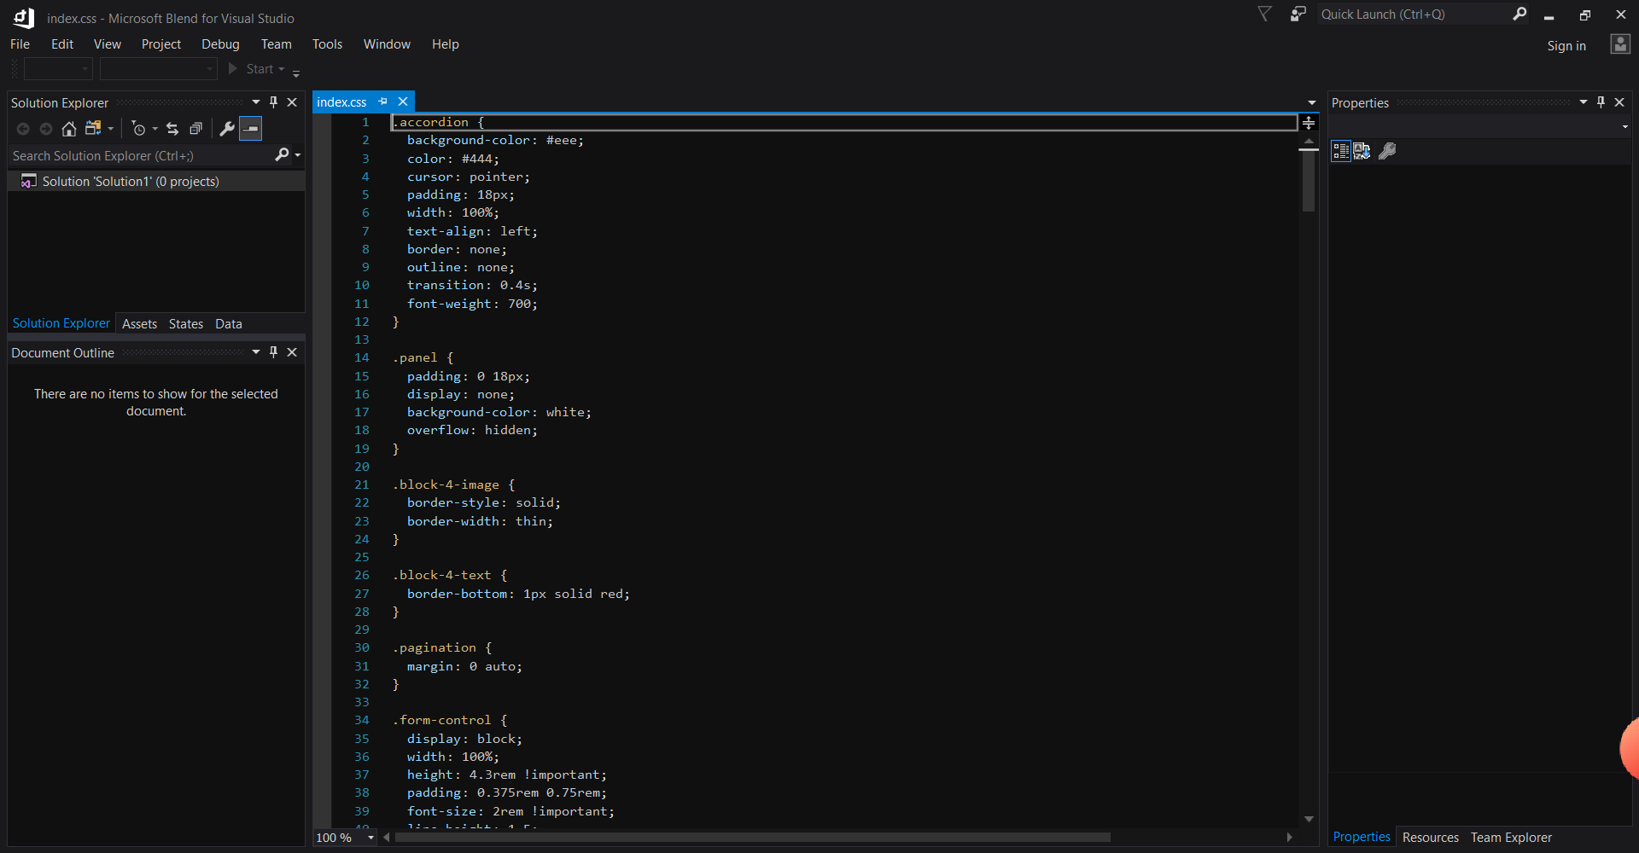

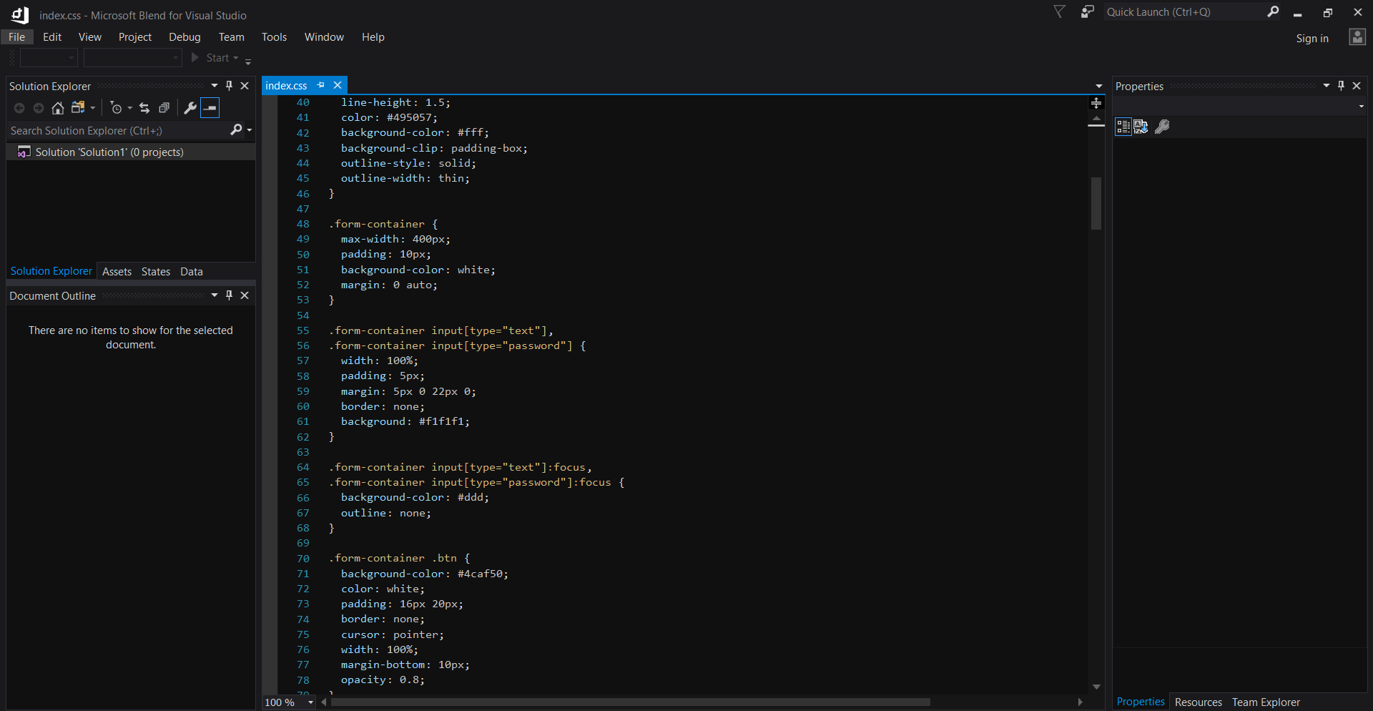

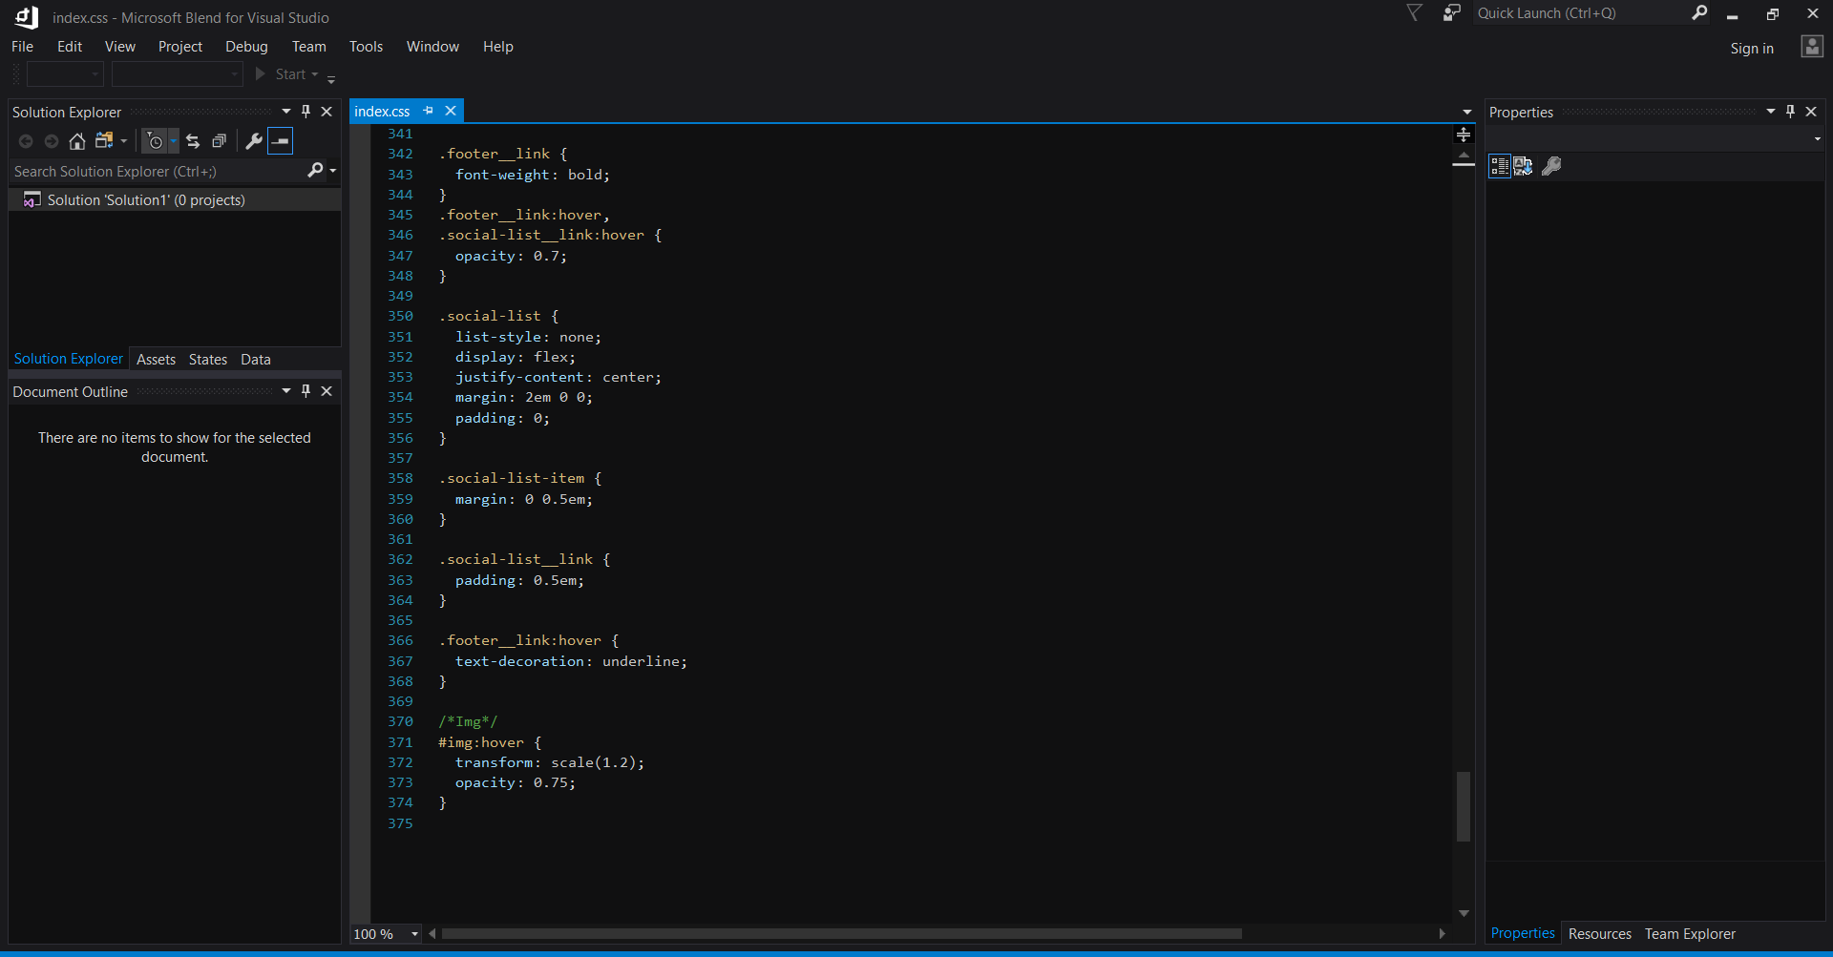

About code:

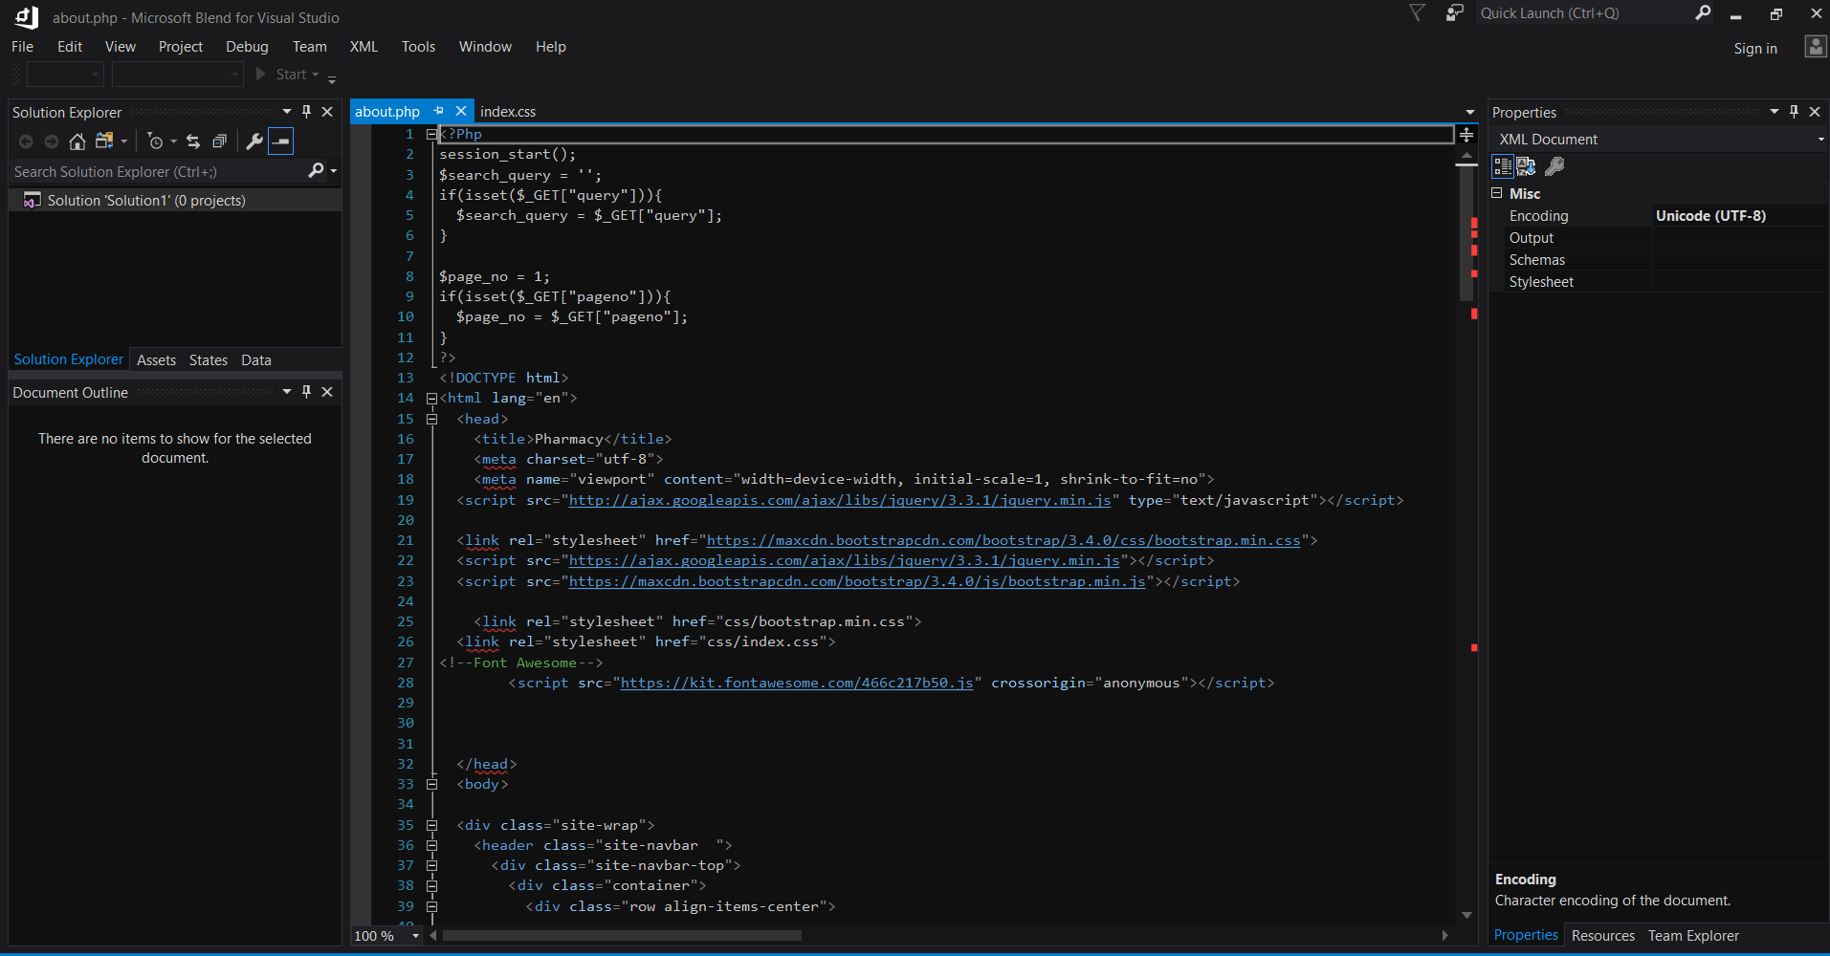

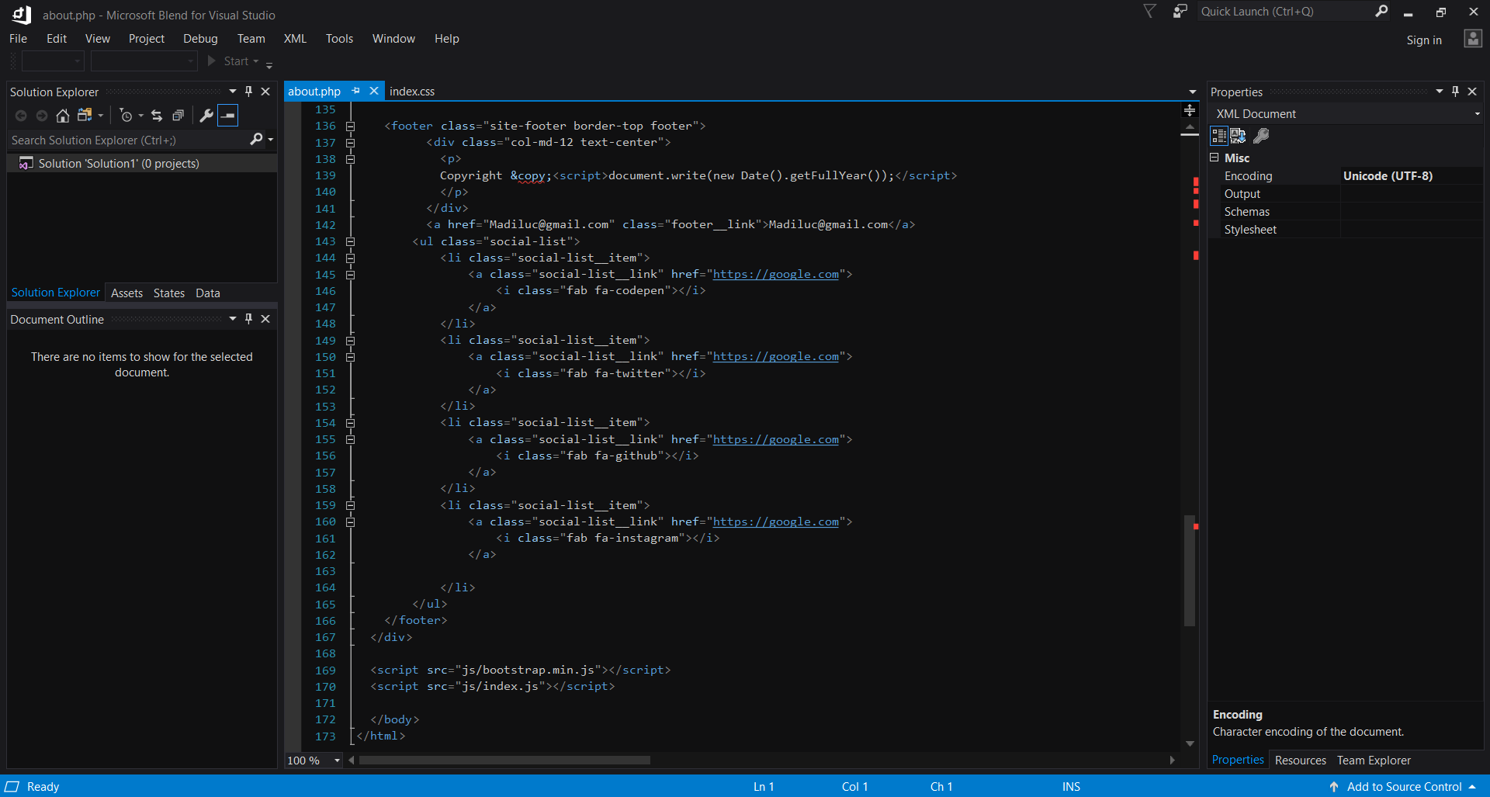

Login page:

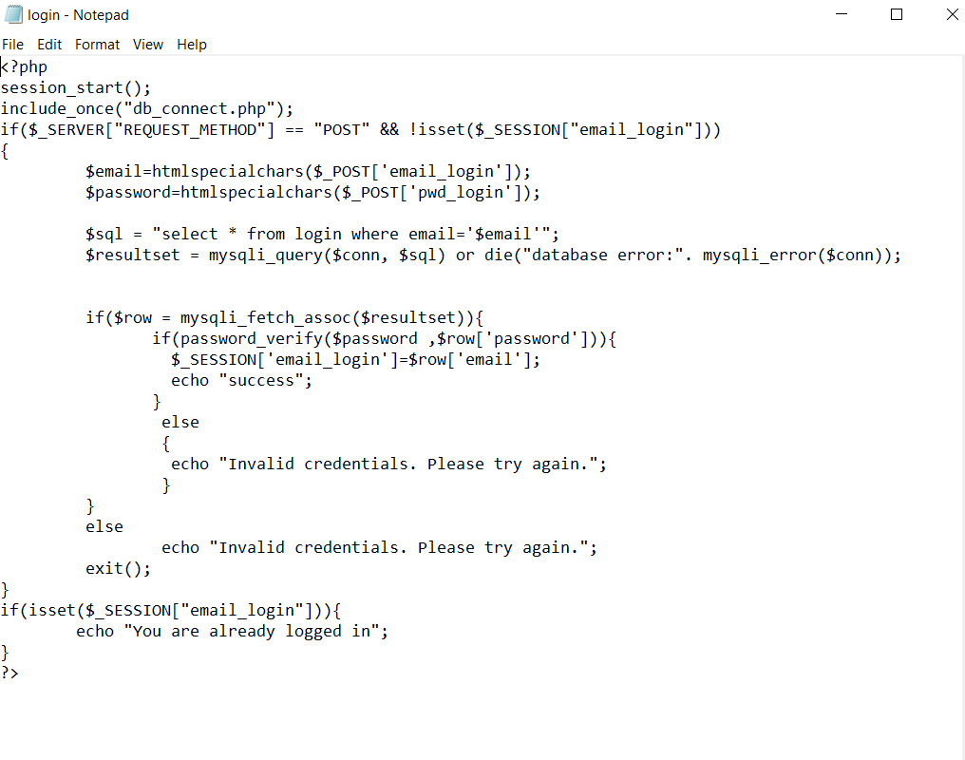

place_order code:

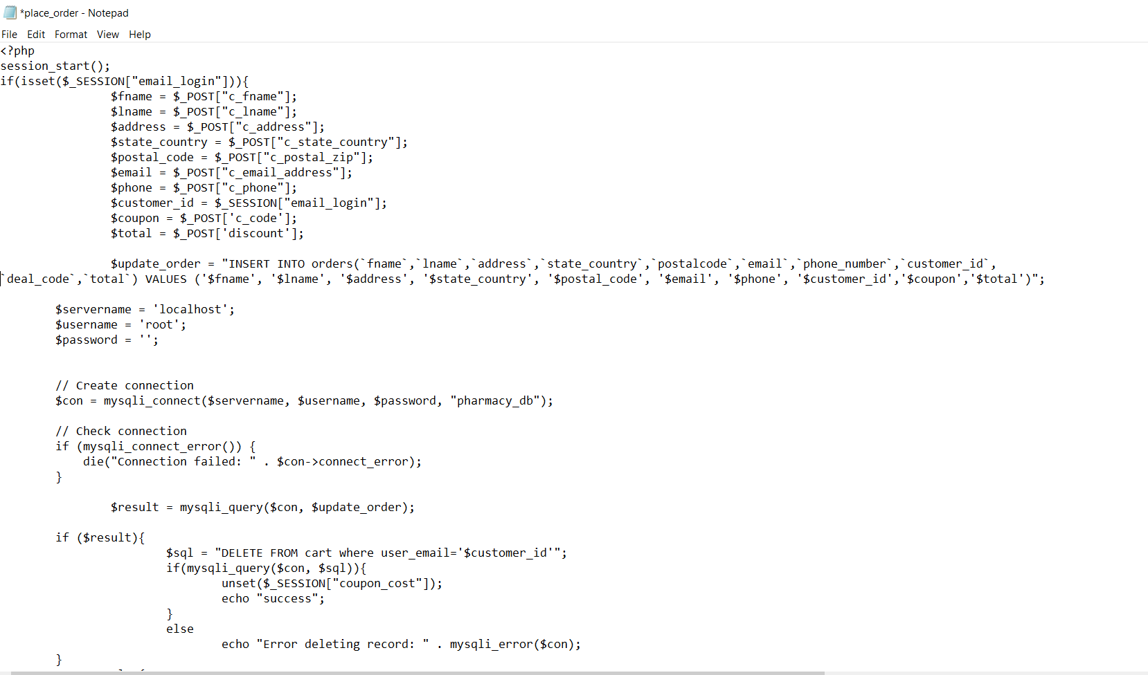

View order code:

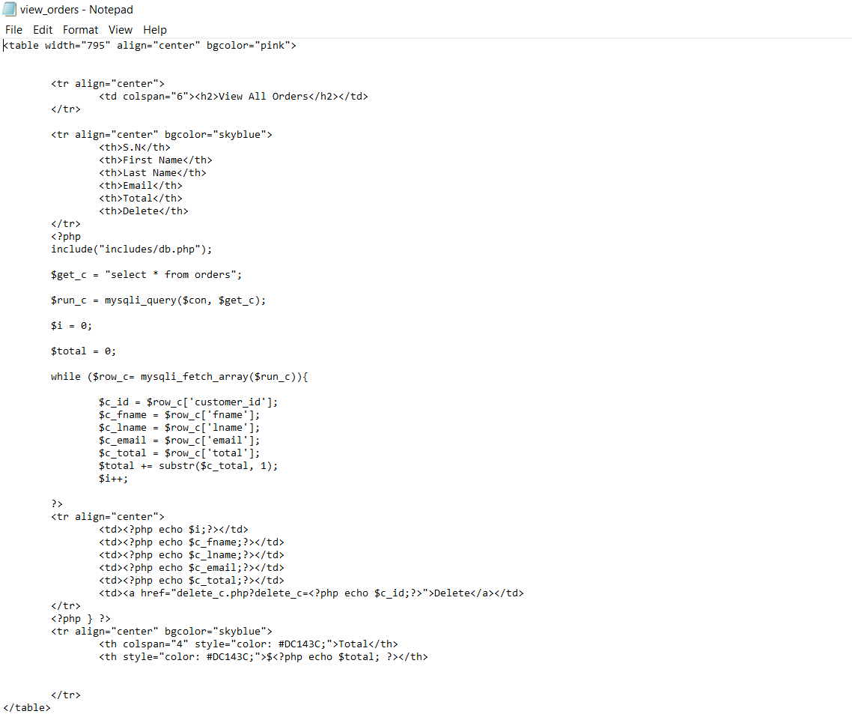

Insert product code:

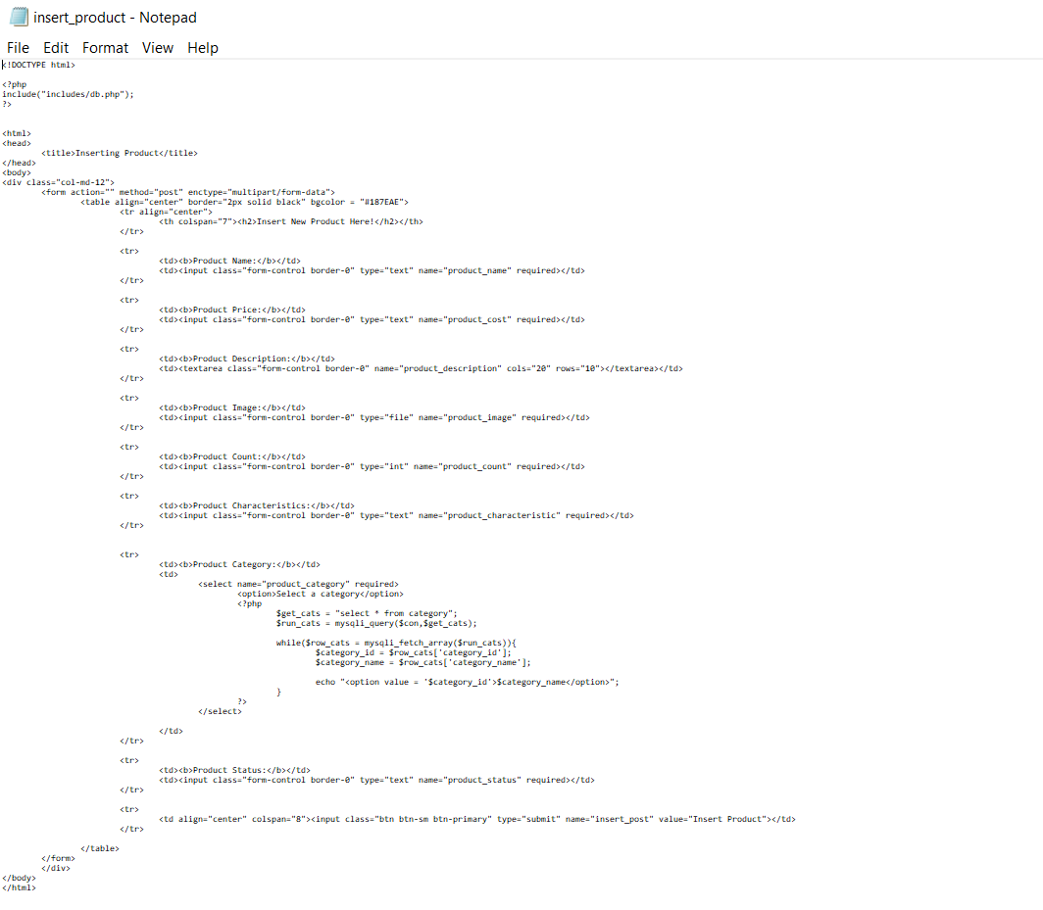

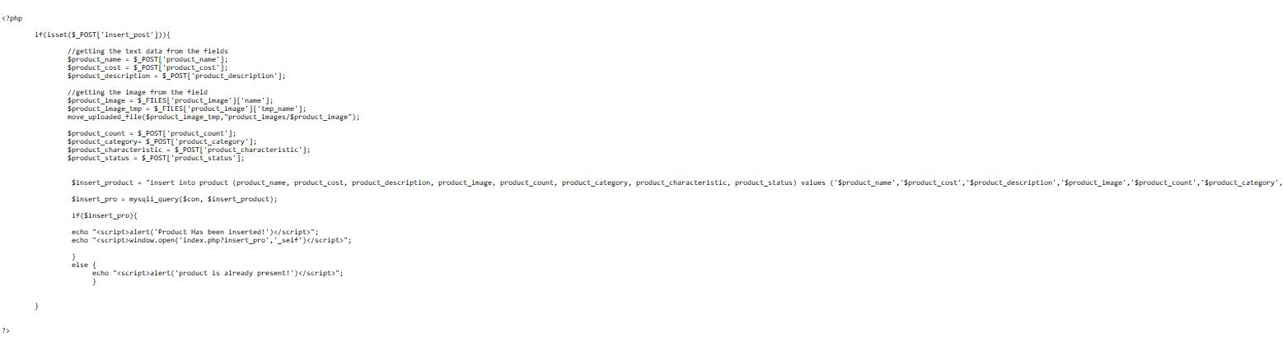

Deleting category code:

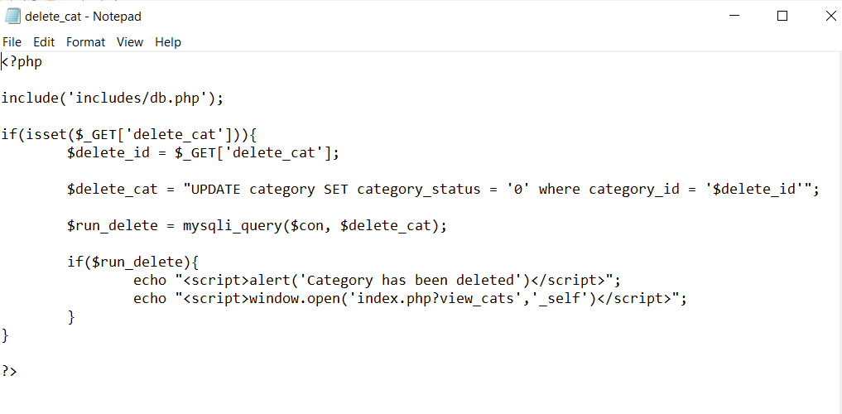

Deleting deal code:

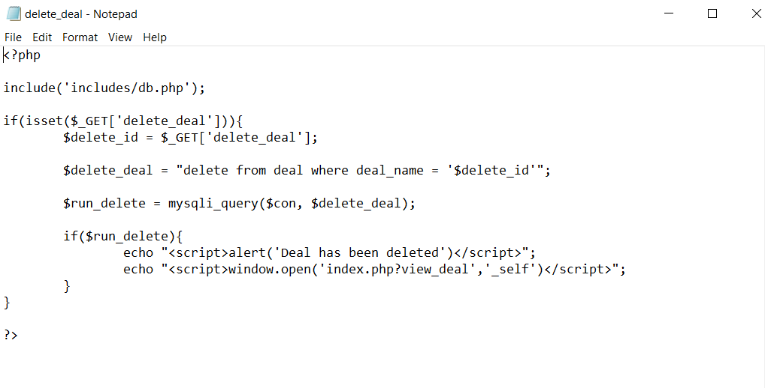

Drive link

Video link:

<https://drive.google.com/file/d/1zZFf6wAQnWBwn6UUJiv8gV6uZnsxrndz/view?usp=sharing>

Code link:

<https://drive.google.com/drive/folders/1OENMB8wBcgR2JGi8rG8PaBOqHDPkrSdM?usp=sharing>

(HINT: PRESS CTRL+CLICK TO OPEN)

Feedback

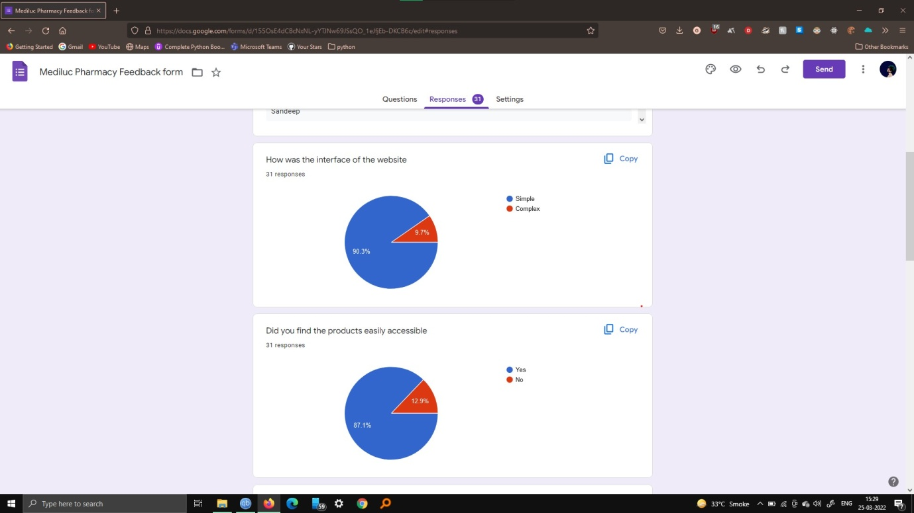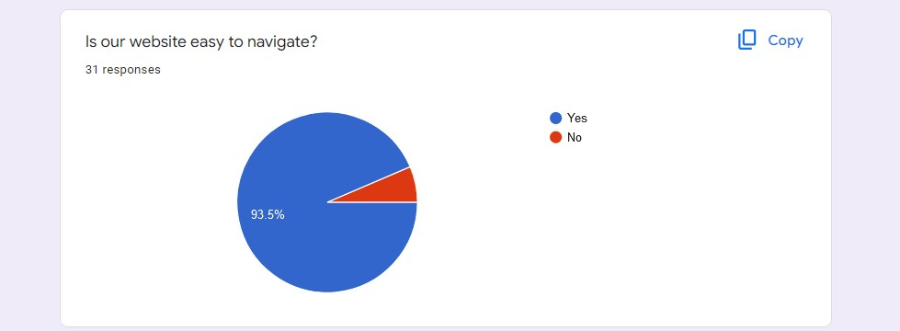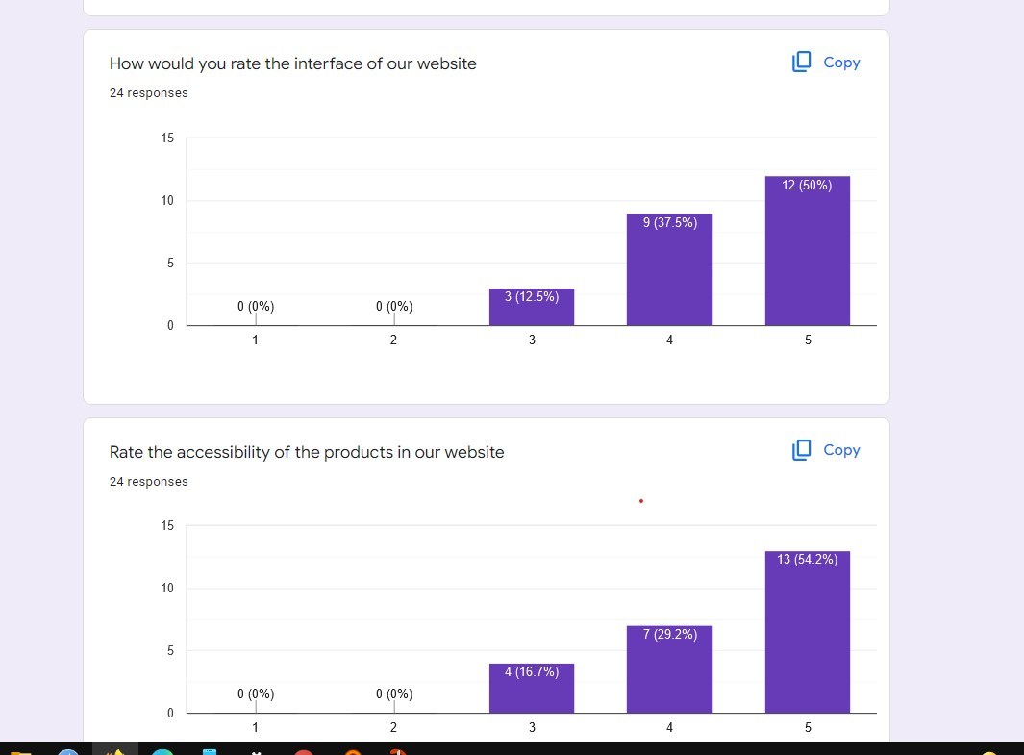

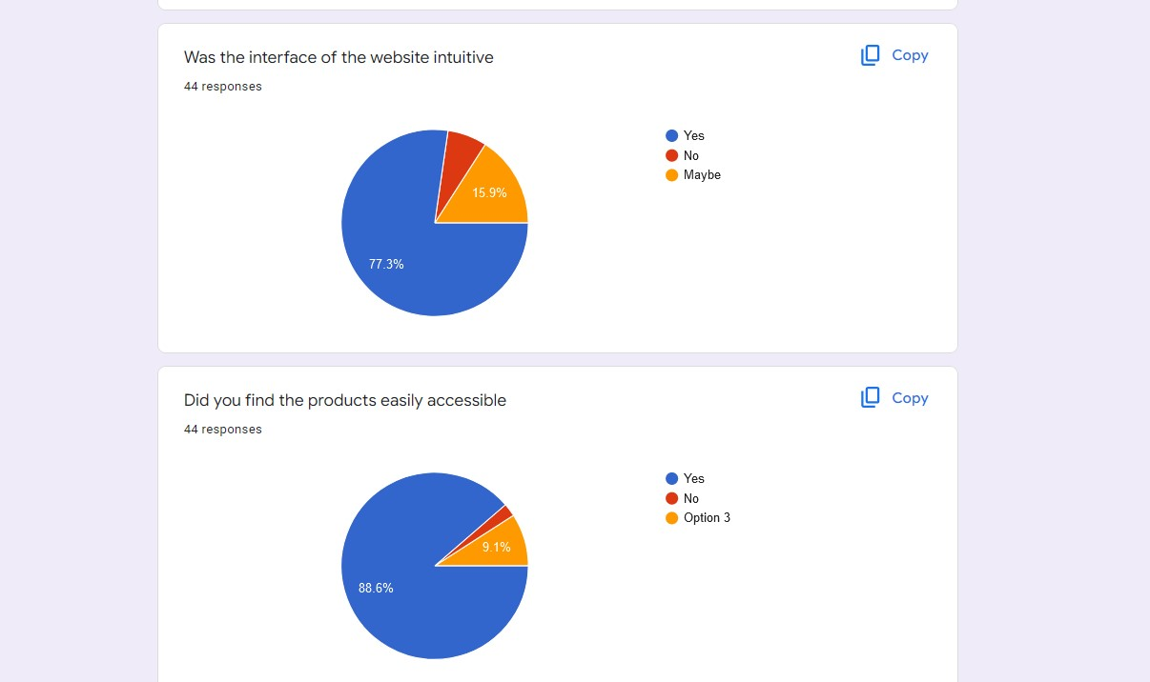

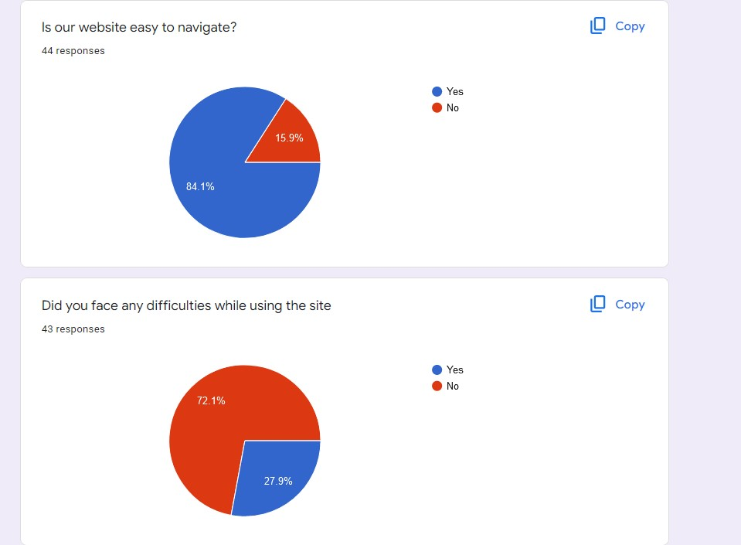

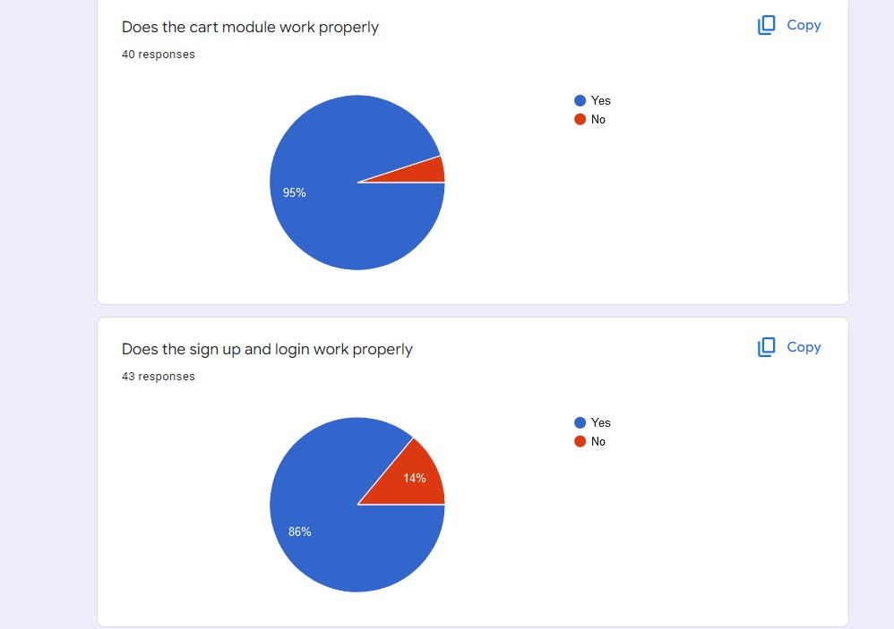

Conclusion

The Internet has become a major resource in modem business, thus electronic shopping has gained significance not only from the entrepreneur's but also from the customers point of view.

For the entrepreneur, electronic shopping generates new business opportunities and for the customer, it makes comparative shopping possible. As per a survey, most consumers of online stores are impulsive and usually make a decision to stay on a site within the first few seconds.

"Website design is like a shop interior. If the shop looks poor or like hundreds of other stoops the customer is most likely to skip to the other site.

Hence, we have designed the project to provide the user with easy navigation, retrieval of data and necessary feedback as much as possible. In this project, the user is provided with an e-commerce pharmacy site that can be used to buy all types of medicine online.